CRYPTIC BIODIVERSITY OF ARID-LAND FUNGI:

FUNGAL ASSOCIATES OF BIOCRUSTS, LICHENS AND PLANTS

By

Mariam Hosseini Marand

Copyright © Mariam H Marand 2023

A thesis submitted to the Faculty of the

SCHOOL OF PLANT SCIENCES

In Partial Fulfillment of the Requirements

For the Degree of

MASTER OF SCIENCE

With a major in

PLANT SCIENCES

In the Graduate College

THE UNIVERSITY OF ARIZONA

2023



**STATEMENT BY AUTHOR**

This thesis has been submitted in partial fulfillment of requirements for an advanced degree at the University of Arizona and is deposited in the University Library to be made available to borrowers under rules of the Library.

Brief quotations from this thesis are allowable without special permission, provided that an accurate acknowledgement of the source is made. Requests for permission for extended quotation from or reproduction of this manuscript in whole or in part may be granted by the head of the major department or the Dean of the Graduate College when in his or her judgment the proposed use of the material is in the interests of scholarship. In all other instances, however, permission must be obtained from the author.

SIGNED:________________________

Mariam Hosseini Marand

APPROVAL BY THESIS DIRECTOR

This thesis has been approved on the date shown below:

_____________________________ _______________

A. Elizabeth Arnold Date

Professor

**ACKNOWLEDGEMENTS**

I would first and foremost like to thank my advisor, Dr. Betsy Arnold, for her amazing mentorship and for giving me the opportunity to join her lab. She was willing to take a chance on me even though I was new to the field of mycology and under a challenging timeline. Dr. Arnold constantly inspires me and I will forever be grateful to have worked with her.

I would like to thank the School of Plant Sciences for giving me the opportunity to study at the University of Arizona and to accomplish this milestone in my career journey. I would also like to thank my committee members, Dr. Marc Orbach and Dr. David Baltrus, for their support and guidance throughout my thesis work. I am grateful to Dr. Samantha Orchard, Dr. Jesse Woodson, and Dr. Mohammed Pessarakli for granting me the opportunity to TA their classes and to learn from them. I greatly appreciate the guidance of my graduate coordinators, Amanda Armendariz and Keenia Shinagawa. I am grateful to Ming-Min Lee and the rest of the Arnold lab for their support and guidance, and for making me feel at home and supported in the lab. I thank my friends and colleagues, particularly Cyrus Mao, Anna Carolina Petronilio, and Neda Arad for their emotional support, kindness, and inspiration.

I would like to thank Michelle Yarnall, Kasi Azhakanandam, Zhongying Chen, and Sara Prado for encouraging me to apply to graduate school, being great career mentors, and always advocating for me. I thank Jessica Kettenbach and Michael Stemkovski for opening my eyes to the world of ecology as an undergraduate research technician and for helping me to realize that graduate school was an option for me.

Lastly I would like to thank my family for their love and for supporting me in moving across the country to obtain my Masters degree. I am lucky to have so many wonderful people on my team.

**DEDICATION**

To my parents, who taught me the importance of education.

To my siblings for their emotional support.

**TABLE OF CONTENTS**

ABSTRACT……………………………………………………………………………………...10

INTRODUCTION……………………………………………………………………………….11

CHAPTER 1: FUNGAL COMMUNITY COMPOSITION IN BIOLOGICAL SOIL CRUSTS SHIFTS IN RESPONSE TO DISTURBANCE AT THE SANTA RITA EXPERIMENTAL RANGE

CHAPTER 1: ABSTRACT………………………………………………………………..…….19

CHAPTER 1: INTRODUCTION………………………………………………………………..20

CHAPTER 1: METHODS……………………………………………………………………….24

CHAPTER 1: RESULTS AND DISCUSSION……………………………………………….…28

CHAPTER 1: CONCLUSION……………………………………………………………..……31

CHAPTER 2: IDENTIFICATION OF FUNGAL SYMBIONTS OF LEAVES AND LICHENS FROM ARID AND SEMI-ARID AREAS OF SOUTHWEST AFRICA, AND THEIR PLACEMENT IN A THREE-CONTINENT CONTEXT

CHAPTER 2: ABSTRACT……………………………………………………………………...43

CHAPTER 2: INTRODUCTION………………………………………………………………..44

CHAPTER 2: METHODS……………………………………………………………………….49

CHAPTER 2: RESULTS AND DISCUSSION………………………………………………….52

RESOURCES……………………………………………………………………………………64

**LIST OF TABLES**

**CHAPTER ONE TABLES:**

**SUPPLEMENTARY TABLE 1.1:** Biocrust OTU assignments and Associated Metadata

**SUPPLEMENTARY TABLE 1.2:** TBAS Taxonomy Assignments and FUNGuild Assignments

**SUPPLEMENTARY TABLE 1.3:** Community Composition of Biocrusts vs Other Substrates

**SUPPLEMENTARY TABLE 1.4:** Indicator species Analysis with Guild and Taxa

**CHAPTER TWO TABLES:**

**SUPPLEMENTARY TABLE 2.1: S**outhern Africa Site Meta Data and Sample IDs

**SUPPLEMENTARY TABLE 2.2: C**hile Site Meta Data and Sample IDs

**SUPPLEMENTARY TABLE 2.3:** Arizona Site Meta Data and Sample IDs

**SUPPLEMENTARY TABLE 2.4:** TBAS Taxa Africa Dataset

**SUPPLEMENTARY TABLE 2.5:** TBAS Taxa All Arid Regions

**SUPPLEMENTARY TABLE 2.6:** Site Condensed Metadata

**SUPPLEMENTARY TABLE 2.7:** OTU Matrix and Meta data Used in Community Analysis

**LIST OF FIGURES**

**CHAPTER ONE FIGURES:**

**FIGURE 1.1:** Study location, representative biocrust, and experimental design………………35

**FIGURE 1.2: P**hylogenetic diversity of biocrust fungi from SRER……………………………36

**FIGURE 1.3:** Richness and diversity of biocrust fungi in each focal pasture at SRER………..37

**FIGURE 1.4:** Community composition of fungi from biocrusts at SRER differed as a function of distance to water tanks……………………………………………………………………..…38

**FIGURE 1.5:** Fungal communities identified from different substrates in the same area differed among substrate types……………………………………………………………………………39

**FIGURE 1.6:** Ecological functions of fungi in biocrusts differ as a function of distance from tanks……………………………………………………………………………………………...40

**FIGURE 1.7:** Although ecological functions differed as a function of distance to tanks, the prevalence of major fungal lineages did not……………………………………………………..41

**CHAPTER TWO FIGURES:**

**FIGURE 2.1:** Locations of arid environments studied………………………………………….58

**FIGURE 2.2:** Phylogenetic diversity of fungi isolated from plant and lichen samples in dryland environments.………………………………………………………………………………….…59

**FIGURE 2.3:** Pearson correlation coefficients to assess relationships among climatic factors.…………………………………………………………………………………………...60

**FIGURE 2.4:** PCA plot mapping climatic factors and their composite correlations with one another…………………………………………………………………………………………..61

**FIGURE 2.5:** Endophyte community composition differ among dryland environments on three continents………………………………………………………………………………………62

**FIGURE 2.6:** Distribution of fungal classes in Ascomycota across three dryland environments……………………………………………………………………………………63

**ABSTRACT**

Organisms in arid and semiarid drylands face environmental challenges such as heat and drought, high salinity and low organic content of soils, and intense ultraviolet radiation. Despite these challenges, dryland environments are some of the most biologically diverse ecosystems in the world: plants that inhabit these ecosystems have evolved unique ways to combat these challenges through distinctive adaptations and, in some cases, symbiotic associations that enhance their resilience. Little work has been done to characterize the fungal lineages that occur as cryptic symbionts of plants in dryland environments. This thesis focuses specifically on characterizing fungi that occur within photosynthetic structures – leaves, lichen thalli, and biological soil crusts – collected from arid and semi-arid environments. In my first chapter I characterize fungi associated with biological soil crusts in the southwestern United States, focusing on their responses to disturbance at the Santa Rita Experimental Range. In my second chapter, I contribute novel data regarding culturable endophytes of lichens and plants in southwestern Africa, and place these into a global context by relating their diversity and composition to climate variables across three continents. Taken together, my work showcases the diversity of fungi that exists within these ecosystems and provides insight into how the distributions of fungi and their hosts may shift in response to changes, such as those associated with land-use, disturbance, and ultimately, climate change.

**INTRODUCTION**

**1.1 The importance and vulnerability of arid and semi-arid ecosystems**

Drylands constitute earth’s largest biome [(Eldridge et al., 2020)](https://www.zotero.org/google-docs/?7V2ISs) covering approximately 41% of earth’s land area [( Hoover et al., 2020, Prăvălie, 2016)](https://www.zotero.org/google-docs/?M7ZUL5). Defined as temperate and tropical lands with a scarcity of water, drylands are home to more than 2 billion people today [(Hoover et al., 2020)](https://www.zotero.org/google-docs/?TG7iju). Climate modeling suggests that drylands are predicted to grow to cover half of global land area by the end of the century [(J. Huang et al., 2016)](https://www.zotero.org/google-docs/?ZiXrAY). The greatest warming has been observed in semi-arid drylands, which are most sensitive to climate change and human activity [(J. Huang et al., 2017)](https://www.zotero.org/google-docs/?KbG49e). Such drylands also are under increasing pressure from development, changes in fire regimes, invasions by non-native species, expansion of agriculture, livestock grazing, and drought, making these landscapes both important and yet, highly threatened in our changing world [(J. Huang et al., 2017; Underwood et al., 2019; Zhang et al., 2023)](https://www.zotero.org/google-docs/?EvECmO).

The pressures of climate change and human activity together result in myriad changes to dryland ecosystems, but most prominent among them is desertification – the degradation of vegetation and loss of plant cover that, with cascading impacts, results in a loss of biodiversity and productivity. In parallel with these pressures, the timing of life cycles and distributions of species are also shifting, with earlier springs and warmer winters increasing pressure from pathogens and parasites [(Archer & Predick, 2008)](https://www.zotero.org/google-docs/?V79xLz). This is particularly visible in soil-borne fungal pathogens such as *Alternaria alternata,* with negative consequences for human health, food security [(Delgado-Baquerizo et al., 2020)](https://www.zotero.org/google-docs/?w4pKf4), and ultimately, the unique functions and biodiversity of dryland ecosystems.

As drylands expand and desertification increasingly threatens both the margins of arid zones and the viability of ecosystems within them, it is important to understand the complexity and diversity of the organisms which inhabit these regions. Two main efforts are indeed: to document existing biodiversity, and to relate the structure of that biodiversity to climate factors, which may help predict future viability of fungal communities as environments become drier, warmer, and have less consistent patterns of precipitation. More broadly, by understanding how organisms have evolved to live in dryland environments, we may be able discover resources such as genes relevant for heat or desiccation tolerance, which may have applications in the future.

Aside from contributing to global warming, human activities introduce threats to drylands through agricultural practices, resource extraction, habitat fragmentation, and the introduction of invasive species [(Zhang et al., 2023)](https://www.zotero.org/google-docs/?H4JIta). While impacts on plants and animals have been studied in some cases, limited research has been devoted to the fungal symbionts that interact closely with plants in such environments. In arid and semi-arid lands, plants ranging from mosses to diverse vascular plants host diverse endophytic fungi [(Y.-L. Huang et al., 2018; Massimo et al., 2015; Zuo et al., 2021)](https://www.zotero.org/google-docs/?oPPJ0h). The ultimate goal of this thesis is to document the existing biodiversity of such fungi in arid and semi-arid lands in areas representing three continents, with special attention to the relationship of fungal diversity and community composition to factors such as disturbance, temperature, and precipitation. Ultimately I hope that my work may contribute in the long term to sustainable land management practices in drylands in order to minimize loss of biodiversity, with an eye to fungal symbionts.

**1.2 Adaptations to arid lands: the roles of fungi in resilience**

Organisms inhabiting arid lands face challenges due to water limitation. This is manifested especially strongly for plants that must grow in conditions with low moisture content in soils, increasing salinization, nutrient deficiencies, low organic carbon, and high solar radiation ([Farooq et al., 2012](https://www.zotero.org/google-docs/?broken=hH5IgT), [Zahedi et al., 2021](https://www.zotero.org/google-docs/?broken=jZFhXl), [Naorem et al., 2023)](https://www.zotero.org/google-docs/?oJeudO). Due to such challenges the plants that inhibit these environments are highly adapted and specialized to be able to tolerate these stressors. For example many arid-adapted plants use crassulacean acid metabolism (CAM) that allows them to close their stomata during the day and fix CO2 at night in order to reduce water loss in water-limited environments [(Cushman, 2001)](https://www.zotero.org/google-docs/?40lwE4). Other plants may produce secondary metabolites that help them to navigate stress, such as in the case of drought-tolerant wild barley, which produces specialized phenols and flavonoids in response to drought stress [(Zahedi et al., 2021)](https://www.zotero.org/google-docs/?um2FCF).

One key element in plants’ mitigation of environmental stress is the establishment of beneficial symbiosis with fungi. Fungi in particular are adept at tolerating extreme environments and are key players in the functionality and balance of these ecosystems due to their versatile lifestyles and phenotypic plasticity [(Coleine et al., 2022)](https://www.zotero.org/google-docs/?yKEWwG). Many fungi in extreme environments have evolved to produce melanin pigments in their cell walls to protect themselves against UV radiation and desiccation, as well as from high concentrations of salts, radiation and metals [(Gessler et al., 2014; Gostinčar et al., 2010)](https://www.zotero.org/google-docs/?AAcWh1). Certain fungi in genera such as *Aspergillus* and *Penicillium* are some of the most xerophilic and xerotolerant organisms known, reproducing under conditions of very low water availability.[(Coleine et al., 2022, Fontana 2020)](https://www.zotero.org/google-docs/?jD2Bv8). Lichenized fungi also can survive extreme desiccation and can be viable after rehydration for as long as two years in desiccation experiments [(Skovgaard, 2002)](https://www.zotero.org/google-docs/?ScRsPg).

Fungi contribute to the resilience of other organisms in arid environments as well. Saprotrophic fungi cycle carbon, nitrogen and phosphorus, which are otherwise in low abundance in these environments [(Coleine et al., 2022)](https://www.zotero.org/google-docs/?W5PNFL). Lichenized fungi form symbioses with green algae and/or cyanobacteria, helping them to survive periods of desiccation through cytoplasmic cavitation as well as via their hydrophobic cell walls [(Honegger, 1998)](https://www.zotero.org/google-docs/?tYqfr4). Endophytic fungi which inhabit plant roots and foliage assist plants to tolerate biotic and abiotic stressors through the production of secondary metabolites and signaling molecules which increase their resilience to stress [(Ali et al., 2018.; Arnold, 2007)](https://www.zotero.org/google-docs/?kDGzZp). For instance metabolites derived from endophytes of a cactus (*Opuntia humifusa*) displayed antifungal properties against fungal pathogen [*Phomopsis*](https://www.sciencedirect.com/topics/biochemistry-genetics-and-molecular-biology/phomopsis) *obscurans,* highlighting their role in protecting plants from pathogens under stressful conditions, when plants are often more vulnerable [(Silva-Hughes et al., 2015)](https://www.zotero.org/google-docs/?BtzC8O).

More generally, drought stress is one of the main hindrances to plant growth, negatively affecting respiration, photosynthesis, and metabolism [(Farooq et al., 2012)](https://www.zotero.org/google-docs/?Iepxzz). Endophytic fungi play a key role in navigating drought and heat tolerance in plants. This can be achieved through physical production of biologically active compounds or secondary metabolites by the fungus that act on plant metabolism [(Ali et al.,](https://www.zotero.org/google-docs/?jJpCa6) 2018) or by the production of plant hormones such as abscisic acid which is associated with water conservation response in plants [(Eid et al., 2019)](https://www.zotero.org/google-docs/?Wy288U). In some cases, water-stressed plants with increased endophytic interactions displayed increased biomass, chlorophyll content, relative water content, and net photosynthesis in comparison to non-host plants under stress [(Dastogeer, 2018)](https://www.zotero.org/google-docs/?pU6gaD).

Based on such foundational work, researchers have taken advantage of drought and heat tolerant endophytes to improve crop resilience to stress. For instance, one study introduced a thermophilic root endophyte (*Thermomyces sp.*)isolated from desert plant *Cullen plicatum* (syn. *Psoralea plicata*) to mediate heat stress in cucumber crops grown in arid environments in Egypt [(Ali et al., 2018)](https://www.zotero.org/google-docs/?JOeCM8). Another study isolated the heat-tolerant endophyte *Aspergillus violaceofucus* from a fern and introduced it to *Glycine max* (soybean), observing that secondary metabolites produced by the endophyte enhanced chlorophyll content and biomass of soy seedlings as well as lowered levels of toxic reactive oxygen species [(Hamayun et al., 2020)](https://www.zotero.org/google-docs/?TvYNyH). Moreover, foliar endophytes can induce greater water retention in the leaf sheath and protect plants from desiccation (Elbersen & West, 1996).

These benefits speak to a great potential of dryland-adapted endophytes, but there is still much work to be done characterizing fungal diversity in arid ecosystems. The aims of this study are to characterize fungal biodiversity across biological soil crusts, plants and lichens in drylands as a first step toward understanding the potential contributions of these resources.

**1.3 Aims of this thesis and explanation of thesis format**

The aims of this thesis are to expand our understanding of fungal diversity in arid environments by characterizing fungal richness and composition locally, and by placing those findings into a global context. More specifically I aim to explore how fungal diversity differs in relation to environmental pressures such as climate-related stressors (heat, drought) and disturbance. Understanding biodiversity today is important in the context of predicting the effects of climate change and increased disturbance by human activity on fungal diversity, as well as on their hosts. Because many fungi influence plant health and resilience, factors that influence fungi are important elements for the future of the ecosystems on which humans depend, both directly and indirectly. This work is detailed in two chapters.

In chapter one, my collaborators and I evaluated the richness and composition of fungal communities associated with biological soil crusts in southern Arizona, and determined how these aspects of fungal community composition varied as a result of disturbance. To capture the diversity of fungi associated with biocrusts, I took a culture-free approach, using Illumina sequencing and bioinformatic tools to assess what fungal lineages are found in biocrust samples, estimate their richness and diversity, determine how these fungi shift as a result of disturbance, and clarify how unique these communities are to the fungi associated with plants in the region. My work is contextualized by two main areas of inquiry: first, documenting the biodiversity of biocrust-associated fungi, and second, understanding how disturbance due to trampling by cattle may influence fungal communities in biocrusts. My study was conducted at the Santa Rita Experimental Range and was framed by existing sampling led by Nicolas Katz, who surveyed disturbance to biocrusts in this area and collected the biocrust samples (Katz, 2022; Katz, 2021). I was responsible for all of the molecular analyses and bioinformatics, statistics, and inferences in this work, resulting in a study that is co-authored by Nicolas Katz and my thesis advisor, Betsy Arnold. The implications of this study will help to understand the impact of disturbance on arid ecosystem functioning in relation to cryptic fungal associates of biological soil crusts, which can be taken into consideration in range land management strategies.

In chapter two, my advisor and I shifted my focus from a single sampling site in southern Arizona to a more global scale, and shifted from fungi occurring as part of biological soil crusts to fungi that occur as endophytes in plants and lichens that inhabit drylands on three continents (North America, South America, and Africa). Here, I characterized previous collections of endophytic fungi by evaluating isolation frequency, counting individual cultures for work done in 2019 in South Africa and Namibia and then sequencing the barcode locus (internal transcribed spacers and 5.8S gene, plus a portion of the nuclear ribosomal large subunit) on the Sanger platform for over 500 of those strains. The aim of my study was to characterize what fungal lineages can be found in each environment as well as how these lineages compared across different arid environments across the globe. In addition I assessed how fungal communities differ as a function of precipitation and temperature. In this work I leveraged previous collections of fungi from Arizona and Chile from the Arnold lab, with the Chilean and African work supported by an NSF Genealogy of Life project, for which the University of Arizona portion was led by Betsy Arnold. Here I used sequence data generated by Shuzo Oita (Chile), and plant records, original cultures, field records, and metadata generated by Betsy Arnold, Shuzo Oita, Alicia Ibáñez, François Lutzoni, Jolanta Miadlikowska, Nathaniel Yang, and Ian Medeiros, with support from Reinaldo Vargas (Chile), Terry Hedderson (South Africa), and Gillian Maggs-Kölling (Namibia). I also used sequence data, plant records, field records, and metadata generated in Arizona by Yu-Ling Huang, Gavin Lehr, Nicolas Massimo, MM Nandi Devan, Dustin Sandberg, Elizabeth Bowman, Nick Garber, and Betsy Arnold, as well as additional student assistants. The implications of this study will give insight into how climatic factors and host diversity drive changes in distributions of endophytic fungi and how these communities may evolve in response to climate change.

**CHAPTER ONE**

FUNGAL COMMUNITY COMPOSITION IN BIOLOGICAL SOIL CRUSTS SHIFTS IN RESPONSE TO DISTURBANCE AT THE SANTA RITA EXPERIMENTAL RANGE

Mariam Hosseini Marand, Nicolas Katz, A. Elizabeth Arnold

**ABSTRACT**

Biocrusts are aggregated microbial communities that exist on the soil surface in arid and semi-arid environments. Comprised of diverse cyanobacteria, algae, lichens, and bryophytes, biocrusts serve important ecosystem functions in dryland ecosystems such as rangelands, where they reduce erosion, improve nutrient cycling, decrease dust, limit soil degradation, and enhance water retention in soils. These functional roles are shaped by the microbial community, including bacteria and fungi, that occur within the crusts and likely influence the crust’s resilience to drought, thermal stress, and disturbance. The purpose of this study was to examine how fungal communities in biological soil crusts vary as a function of disturbance, with a special focus on trampling by livestock at the Santa Rita Experimental Range (SRER; Arizona, USA). In each of three pastures at SRER, we collected crusts along three transects centered on a watering tank for cattle. Collection points on each transect were located at 0 m, 500 m, and 1000 m from the tank, with the expectation that disturbance would be greatest at the water source and would decrease at greater distances from the tank. Through amplicon sequencing on the Illumina platform, we found that fungi associated with biocrusts differed in richness and composition as a function of disturbance. Biocrusts in the areas with the least disturbance contained the lowest richness of fungi. Distinctive fungal species with different ecological functions were associated with crusts from high- and low-disturbance areas. When compared against data collected across the region, fungal communities in biocrusts were distinct from those in bulk soil, rhizosphere soil, or roots, suggesting an important role of biocrusts in harboring unique fungal diversity. Overall our results suggest that biocrust fungi may play a highly important role in nutrient cycling in high disturbance environments, but that the loss of fungal mutualists may limit the health or resilience of biocrusts when disturbance is severe.

**INTRODUCTION**

Biocrusts are aggregated microbial communities that exist on the soil surface in arid and semi-arid environments. Defined by the emergent structures that form crusts in the uppermost millimeters of soil, biocrusts represent intimate associations between soil particles, photoautotrophic organisms (cyanobacteria, algae, lichens, and bryophytes), and heterotrophs (including bacteria, archaea, and fungi) [(Belnap & Lange, 2003)](https://www.zotero.org/google-docs/?YbmVbS). Biocrusts serve important ecosystem functions in dryland ecosystems such as rangelands, where they reduce erosion, improve nutrient cycling, decrease dust, limit soil degradation, and enhance water retention in soils ([Belnap & Lange, 2003; Ferrenberg et al., 2017; Weber et al., 2022](https://www.zotero.org/google-docs/?oofX4i)). Overall biocrusts can be definednot only by their composition, but by their habitat, structure, and function [(Weber et al., 2022)](https://www.zotero.org/google-docs/?of9eGw).

At a global scale, biocrusts can be found primarily in environments where water is limited and thereafter there is limited cover by vascular plants [(Weber et al., 2022)](https://www.zotero.org/google-docs/?acA1hA). For these reasons they are primarily found in arid and semi arid drylands, where biocrust samples can compromise up to 70% of land cover locally [(Rutherford et al., 2017)](https://www.zotero.org/google-docs/?Bj3dyZ) and represent approximately 12% of terrestrial land cover globally [(Rodriguez-Caballero et al., 2018)](https://www.zotero.org/google-docs/?cY9dDh). Biocrusts are extremotolerant and able to use small amounts of water for optimal photosynthetic activity. They can contain as much productivity and higher chlorophyll content than vascular plants in the same environment [(Belnap & Lange, 2003; Raggio et al., 2014)](https://www.zotero.org/google-docs/?z9Vwmr).

Composition and cover of biological soil crust samples can vary both among geographic locations and as a function of environmental factors such as precipitation, temperature, soil texture and chemistry [(Rosentreter & Belnap, 2001)](https://www.zotero.org/google-docs/?hHcP0r). For instance, biocrusts in highly alkaline soils are generally dominated by cyanobacteria, whereas green algae dominate crusts in highly acidic soils (Grondin & Johansen, 1995). Similarly, biocrust lichens such as *Aspicilia fruticulosa* can serve as indicators of soils with high levels of calcium carbonate [(Rosentreter & Belnap, 2001)](https://www.zotero.org/google-docs/?broken=buj78H). Because biocrusts have many important ecosystem functions, including soil stabilization and erosion control, nutrient cycling, and hydrologic cycling [(Bates et al., 2012; Eldridge et al., 2020; Weber et al., 2022)](https://www.zotero.org/google-docs/?Uk2T0q), there is growing interest in their impacts on land conservation and the protection and re-establishment of ecosystem services in drylands worldwide.

*Biocrusts in ecosystem functioning in arid environments*

Water limitation is a defining feature of arid landscapes, which have higher evaporation rates than precipitation [(Hoover et al., 2020; Naorem et al., 2023)](https://www.zotero.org/google-docs/?8SMFXT). For this reason, water conservation in dryland ecosystems is crucial to the stability of such environments, which often include high biodiversity, endemic species, and numerous desirable characteristics for human use.

Biocrust coverage can beneficially impact hydrology across the landscape. Due to the morphology and composition of biocrusts, increasing biocrust coverage reduces the time needed for ponding and water runoff while simultaneously reducing sediment production and increasing moisture storage in the soil [(Eldridge et al., 2020)](https://www.zotero.org/google-docs/?QprYWY). Increased soil moisture is beneficial for other soil-dwelling microbes as well as nearby plants, such that biocrusts can serve as ecosystem engineers in dryland systems. Furthermorebiocrust cover can promote soil nitrogen and plant health via atmospheric nitrogen fixation, often benefitting vascular plants whose roots are in proximity [(Delgado-Baquerizo et al., 2014; Ferrenberg et al., 2017)](https://www.zotero.org/google-docs/?RWI2pE). Native plants that evolved with biocrusts particularly benefit from biocrusts, which can suppress exotic plant emergence and promote native emergence [(Bowker et al., 2022)](https://www.zotero.org/google-docs/?uOe1Rg), thus speaking to the durability of plant communities in threatened drylands worldwide.

*Impacts of disturbance on biocrusts*

Biocrusts are highly sensitive to disturbance. Their coverage is predicted to decrease by 25-40% within the coming 65 years due to climate change and land-use intensification [(Rodriguez-Caballero et al., 2018)](https://www.zotero.org/google-docs/?RJUrzy), with serious implications for environmental health in and beyond dryland ecosystems themselves. A loss of biocrust coverage can damage key ecosystem processes like nutrient cycling, soil water retention and erosion and dust control, all of which can affect other organisms within the ecosystem. In field experiments where plots were scraped to remove biocrusts, nitrogenase activity could not be detected as long as 9 years after their removal, suggesting that damage to biocrusts can have long-term impacts [(Belnap, 1995](https://www.zotero.org/google-docs/?03LoUX)). Moreover, the total nitrogen content of soils without biocrusts typically is much lower than biocrust-containing plots [(Belnap, 1995)](https://www.zotero.org/google-docs/?aOzUDP). This suggests that the biocrusts are a dominating source of fixed nitrogen and that soil dwelling microbes play a less significant role in nutrient cycling.

Similarly, effects have been seen in grazing pastures where disturbance by livestock can damage biocrusts. Katz (2022) showed that in a rangeland in southern Arizona, intensity of land use by cattle was associated with a decrease in biocrust cover. Similarly [Concostrina-Zubiri et al., (2017)](https://www.zotero.org/google-docs/?SK8fAj) showed that reduction in biocrust cover and changes in composition due to grazing cattle had a direct impact on water holding capacity due to a loss of fruticose lichens. In such environments, significant impacts on nutrient cycling can persist for an extended period of time beyond the timeframe of active disturbance. For example, in one study in grazing plots, soil and plant nitrogen – as well as nitrogenase activity levels – were significantly lower 30 years after the grazing had ceased versus areas in which livestock grazing had never occurred [(Belnap, 1995)](https://www.zotero.org/google-docs/?QCShWR).

Such damage has lasting impacts on ecosystems. In semi-arid grasslands, for example, increases in the abundance of non-native plants and losses of native plant diversity often occur following disturbance events [(Bowker et al., 2022; Pearson et al., 2018; Slate et al., 2019; Underwood et al., 2019)](https://www.zotero.org/google-docs/?3pwqD5). The loss of biocrust cover makes way for non-native plants to become established and promotes emergence of non-native seedlings, as has been documented by exotic grass *Avena fatua* in Southern California grasslands [(Hernandez & Sandquist, 2011)](https://www.zotero.org/google-docs/?QSCIks). Changes in plant community and the loss of native plants ultimately impacts macrofauna at these sites as well. For instance, reduced native shrub cover can create a greater distance between shrubs and therefore less cover from predation for small animals [(Belnap, 1995)](https://www.zotero.org/google-docs/?a7ZlmX). In ecosystems with low plant coverage, biocrusts also hold together the soil surface and prevent soil erosion as well as dust storms. Damage to biocrusts is associated with a higher prevalence of airborne dust, which in turn has been shown to promote greater instances of Valley Fever in the American southwest [(Lauer et al., 2020)](https://www.zotero.org/google-docs/?2hoFtj).

*Roles of fungi in biocrusts*

Biocrusts harbor diverse microbial communities consisting of bacteria, archaea, and fungi [(Weber et al., 2022)](https://www.zotero.org/google-docs/?HicGCk). Within biocrust samples themselves, disturbance can impact biocrust organisms differentially. For example, warming as well as disturbance from human trampling reduce lichen and moss composition while increasing the composition of cyanobacteria within biocrusts (Ferrenberg et al. 2015). These shifts in composition are also seen at the genus level: for instance, in warming experiments, cyanobacteria have switched in dominance from *Microcoleus vaginatus* to a more thermotolerant species, *Microcoleus steenstrupii* (Garcia-Pichel et al., 2013). More generally, it is thought that microbes, including fungi, that occur in biocrusts likely are important for their overall function, growth rate, and resilience to stress. However, little is known about the impacts of disturbance on fungi in biocrusts, nor how fungal communities are structured in biocrusts in areas such as the American southwest.

The aim of this study is to assess the effects of disturbance by trampling cattle on fungal communities that occur within biological soil crusts in a semi-arid region of North America. We focus on the Santa Rita Experimental Range of southern Arizona, where our measures of fungal community diversity and structure are among the first in southwestern US biocrusts. We surveyed biocrusts in areas at various distances from livestock tanks and used culture-free Illumina sequencing to characterize fungal communities. Here we describe the composition, diversity, and structure of fungal communities in biocrusts in this region, and highlight the impacts of disturbance upon them.

**METHODS**

Live biocrust samples were collected in August 2021 at the northwestern Santa Rita Experimental Range (SRER) near Sahuarita, Arizona, USA (Katz 2022). The SRER is a 21,000 hectare research range administered by the University of Arizona College of Agriculture, Life and Environmental Sciences. It is located at the base of the Santa Rita Mountains south of Tucson. It is home to one of the oldest biological field research stations in the United States, founded in 1902, and its rich biological diversity encompasses Sonoran desert scrub, semi-desert grassland, and madrean evergreen woodland biotic communities (McClaran 2003). The area used for this study includes actively and historically grazed semi-arid grasslands with Sonoran Desert vegetation. Plants in this area include *Parkinsonia microphylla*, *Ferocactus wislizenii*, *Opuntia engelmannii*, *Opuntia spinosior*, *Prosopis velutina*, and diverse grasses.

In each of three grazing pastures at the SRER, we selected one plot adjacent to a cattle watering tank (Fig. 1.1). To capture increasing degrees of disturbance, plots were sampled at 0m, 500m and 1000m from each tank, on each of three transects (Fig. 1.1). The closest proximity to the tank (0m) had the highest level of disturbance by cattle trampling, and 1000m from the tank had the least amount of disturbance (Fig. 1.1). At each point on each transect, a 1m2 plot was established up to three biocrust samples were collected, for a total of 75 biocrust samples. Biocrust samples were collected in Petri dishes and then air dried in the lab for 12 hours prior to molecular analysis (Katz 2022).

*Molecular analysis*

Representative samples of each biocrust sample were collected and placed in 2ml microcentrifuge tubes prior to DNA extraction. Care was taken to include limited amounts of soil, except for that adhering to the crust itself.

Samples were ground via bead-beating with sterile silicone beads. Total genomic DNA was extracted via the Qiagen DNEasy Powersoil Kit following the manufacturer’s protocol (Qiagen, Hilden, Germany). An extraction blank was processed alongside biocrust samples as a negative control, and a mock community of fungal DNA [(Daru et al., 2018)](https://www.zotero.org/google-docs/?sqj7Ba) was included as a positive control. DNA samples were processed for PCR and library preparation at the University of Arizona Microbiome Core by amplifying the nuclear ribosomal internal transcribed spacer regions (ITS) and 5.8S gene. Products were quantified via Qubit fluorometer and processed for sequencing of ITS1 on the Illumina MiSeq 2x300bp platform.

*Bioinformatics*

Raw reads were demultiplexed via *VSEARCH* (Rognes et.al, 2016) and quality checks were performed using *FastQC* (Andrews, 2010). *VSEARCH* was then used to trim sequences based on quality scores, resulting in 150 base pair reads. Chimeras were removed de novo via *VSEARCH*. Operational taxonomic units (OTUs) were assigned and clustered using 95% similarity (Rognes et.al, 2016). The OTU dataset was then filtered from 3523 OTUs to a final dataset of 338 OTUs (Supplementary Table 1.1) by the following criteria: OTUs were retained if they were absent from negative controls, had a read number ≥ 5, were present in more than one sample, and were not present in the mock community.

*Phylogenetic analysis*

Representative sequences for each OTU were placed phylogenetically by TBAS (Carbone et. al. 2019). Placement was accomplished with maximum likelihood under the evolutionary placement algorithm with the pezizo_v2_1 reference set and default parameters. Ecological guilds were determined via TBAS referencing the FUNGuild database (Nguyen et.al, 2016). (Supplementary Table 1.2)

*Statistical analyses*

Species richness of fungi in biocrust samples (i.e., the number of OTUs in sample) was evaluated as a function of distance from the water tanks. Richness values were natural log (ln) transformed to approximate normality. Statistical significance was calculated via ANOVA with richness as a main effect and pasture as a random factor, which allows for variation among pastures to not obscure potential impacts of distance from tanks. Shannon diversity was calculated as a complementary measure that considers relative abundance. Diversity was calculated using the R studio package *vegan* (Jari et.al, 2022) and analyzed as above, but without the ln transformation.

To measure differences in community composition of fungi, Bray-Curtis dissimilarity values, which reflect differences in relative abundance and species components between biocrust samples, were calculated in *vegan* (Jari et.al, 2022). Non-metric multidimensional scaling (NMDS) plots were generated to visualize community composition differences between samples by disturbance levels and pasture. Their significance was analyzed via PERMANOVA with distance as a main effect.

Fungal community composition of biocrusts vs. other substrates in the environment was generated using data from a concurrent study on native and invasive grasses in the same region by Taylor Portman, Malak Tfaily, and Betsy Arnold [(see Portman, 2023)](https://www.zotero.org/google-docs/?XhoH5Y). Data from Portman (2023) were generated from roots, leaf litter, rhizosphere soil, and bulk soil in areas associated with various grass species, including native and non-native species. Sample preparation followed the present study, as described by Portman (2023), and the sequencing process was identical. The data set was demultiplexed as above, then combined with the biocrust data in order to generate a composite data set, to which the quality control criteria listed above were applied. (Supplementary Table 1.3) Fungal community dissimilarities were calculated using Bray-Curtis distances in *vegan* (Jari et.al, 2022), differences were visualized by NMDS, and their significance was analyzed via PERMANOVA with substrate type as a main effect.

*Indicator species analysis and ecological guilds*

Indicator species analysis takes into consideration species abundances in order to determine which species are the most impactful in defining communities under a particular set of circumstances, such as environmental factors. This can be used to determine the impacts of a changing environment and as an indicator of the biotic or abiotic state of the environment (De Cáceres & Legendre, 2009). Indicator species analysis was performed using the R package *indicspecies* in order to determine the most significant OTUs at different distances from tanks and among pastures. To assess how ecological functions of biocrust fungi may shift in response to disturbance, ecological guilds were assigned to each indicator species (OTU) using TBAS and the FUNGuild database (Supplementary Table 1.4). The proportion of fungi representing each ecological guild was determined by the number of samples which contained each OTU, and thereafter each ecological guild associated with that OTU (Supplementary Table 1.4). Results were visualized via *ggplot2* in Rstudio (Wickham H, 2016).

**RESULTS AND DISCUSSION**

Overall biocrusts from the Santa Rita Experimental Range harbored diverse and abundant fungi (Fig. 1.2). From 75 biocrust samples, a total of 10,326,442 raw sequencing reads were generated. These represented 338 unique OTUs after extensive quality control. (Supplementary Table 1.1)

Fungi in four phylawere detected: Ascomycota, Basidiomycota, Chytridiomycota, Mortierellomycota. The majority were Ascomycota, especially in the Pezizomycotina. Phylogenetic reconstruction of crust fungi reveals multiple classes of Ascomycota (Fig. 1.2). When comparing clades of Ascomycota found in highly disturbed and undisturbed biocrusts samples we did not observe any distinct differences in the frequencies of represented clades (Figure 1.7).However, differences in composition can be seen at the OTU level and in ecological functions across all biocrust samples, as described below.

*Species richness*

Illumina sequencing of genomic DNAs revealed an average of 80 fungal OTUs in biocrusts at the sites nearest the water tanks (highest disturbance), and an average of 65 OTUs at the sites farthest from the tanks (lowest disturbance). While not statistically significant, there was a strong trend such that richness varied as a function of distance when pasture was a random factor (Fig. 1.3). Richness generally decreased as a function of distance from the water tanks with lowest disturbance biocrusts having the lowest species richness (Fig. 1.3). Although high levels of disturbance have been described to negatively impact species richness, later successional stage communities often have lower species richness in comparison to previous successional stages due to having less competition and established communities [(Qianwen et al., 2022)](https://www.zotero.org/google-docs/?zQnpbY). However, when we examined diversity (Shannon index) we did not see the same trend (Fig. 1.3): when only the number of OTUs is represented (richness), we see a decrease with increasing distance, but when abundance is considered, we lose that signal. Thus it may be the case that particular taxa, being highly abundant, influence the diversity values. This trend has been mirrored in previous studies where biomass of active bacteria and fungi was six to seven times higher in untrampled areas than in trampled areas [(Belnap, 1995)](https://www.zotero.org/google-docs/?nFN7Pq).

*Community composition*

Community composition of fungi in biocrust samples differed significantly as a function of disturbance and pasture (Fig. 1.4). Individually each pasture contained significant differences in community composition as a function of distance from tanks, except in one pasture for which there was a strong trend (Fig. 1.4).

Fungi observed in biocrusts were distinctive relative to those in other substrates in the area. Fungal communities among samples collected from biocrust, soil, litter, rhizosphere soil, and roots differed significantly in their composition (Fig. 1.5). Fungi from roots, rhizosphere soil, and bulk soil all cluster separately of biocrusts (Fig. 1.5). These results suggest that the fungal species in biocrust samples and in arid environments overall are likely specialized to particular substrates. As a consequence, damage to fungal communities in biocrusts may not be addressed simply by re-vegetation, and each substrate should be considered an important element of dryland biodiversity. In turn, the overlap between fungal communities in litter and biocrust samples is likely due to decomposing saprotrophic fungal species found in both sample types as well as endophytes from decaying plant hosts in the litter and in mosses from biocrust samples.

*Ecological guilds*

The prevalence of particular ecological guilds shifted in response to disturbance. Most distinctly there was a higher prevalence of animal pathogens in high disturbance areas, which also exhibited a loss of lichen-associated and lichen forming species (Fig. 1.6). These results suggest that high disturbance contributes to changes in the species composition and abundance of key species in biocrusts samples and that these changes have consequences for the ecological functioning of fungi in biocrust samples.

One such fungus found in the low disturbance dataset yet not in the high disturbance samples, as detailed in Supplementary Table 1.4, was *Peltula* sp. *Peltula* is a lichenized fungus that forms symbiotic relationships with cyanobacteria. It benefits these organisms by absorbing 89-93% of radiation in the fungal cortex layer, protecting the lower cyanobacteria-containing photobiont layer (Budel and Lange, 1994). This lichenized fungus also contributes to the water holding capacity of the biocrust as it forms cavities within its medulla to store water [(Yang et al., 2022)](https://www.zotero.org/google-docs/?9urC8f).

In contrast, in the high disturbance areas, the fungus *Phialemonium* was identified as an animal pathogen. It was not present in the low disturbance samples. *Phialemonium* is a soil- and waste-dwelling, opportunistic pathogen of humans that can cause serious health effects such as endocarditis (inflammation of the heart) in immunocompromised people [(Proia et al., 2004; Rivero et al., 2009)](https://www.zotero.org/google-docs/?YIPgLf). These findings imply that changes in fungal composition in crusts due to high levels of disturbance not only has negative effects on the health of other soil crust organisms and the environment, but potentially on human health as well, and argues for linking biocrusts, environmental change, fungi, land use, and human health into a OneHealth framework.

**CONCLUSIONS AND FUTURE DIRECTIONS**

This study is the first to our knowledge to characterize biocrust-associated fungi in the semi-arid southwestern US, and the first to consider how such fungi may be influenced by localized disturbance. We show that fungi associated with biocrusts are species-rich, phylogenetically diverse, ecologically diverse, distinct under different disturbance regimes, and distinct from fungi in soils, roots, and rhizosphere soils in the same region. These together suggest that dryland biocrusts may be important compartments of fungal biodiversity in arid and semi-arid systems.

Several factors are important in interpreting our findings. First, we cannot confirm from our data whether the fungi detected in the biocrusts were living and active, or represented spores or dead tissue, a matter for future study. Here, metagenomics/transcriptomics and culture-based surveys could be helpful.

Second, we do not have observational data of cattle to confirm that areas near tanks were more severely trampled, though this is affirmed by observations in the field (Arnold, personal communication). We observed hoof prints, damaged or absent crusts, bare soil denuded of variation, and other elements of disturbance near tanks that could not be found at 500m or 1000m away.

Third, our sample represents only a snapshot in time. While that makes generalization of our results somewhat difficult, we note that snapshots often capture standing diversity well (e.g., U’Ren et al. 2019) and that our data provide a useful baseline for future studies.

Several areas for future study emerge from this work. First, we would like to validate the sampling assumptions of more disturbance by cattle near watering tanks through incorporating cattle movement data from SRER. These data are currently being collected by GPS-based tracking in grazing studies at the SRER.

Furthermore, to assess the recovery of biocrust samples after disturbance events it would be important to do time interval sampling to monitor the succession of biocrusts, and their fungi, once these disturbances have been removed. Previous studies have characterized the timing and succession of cyanobacteria and algae communities recovery in natural environments [(Weber et al., 2016)](https://www.zotero.org/google-docs/?JQH4Ci) but not with a focus on fungal communities – aside from the re-establishment of lichen communities in biocrust communities that have been artificially restored [(Chiquoine et al., 2016)](https://www.zotero.org/google-docs/?yoPHDo). Along these lines, we note that FUNGuild provides only a hypothetical function; as such, functional analyses to validate proposed roles of fungi in biocrust samples would be useful.

More broadly, our study provides a perspective on the diversity and localized distributions of biocrust fungi in the context of disturbance, providing baseline biodiversity and compositional measures that can be revisited in the future to detect more general impacts of climate change, or processes of recovery. By highlighting the potential importance of fungal communities within biocrust samples, our study provides a basis for evaluating their potential roles in ecosystem functioning as well as the implications that may arise from damaging such communities in a dryland region.

**ACKNOWLEDGEMENTS**

We thank the University of Arizona Santa Rita Experimental Range for permission to conduct field research there. We especially thank Brett Blum for helping us find study sites, Hector Elias for access, and Mitch McClaran for supporting the opportunity to conduct this work through the Agriculture Experiment Station. We thank Taylor Portman for sharing data, which were gathered in partnership with Malak Tfaily. For funding we thank the School of Plant Sciences and the College of Agriculture, Life and Environmental Sciences at the University of Arizona. Additional support was provided by United States Department of Agriculture - National Institute of Food and Agriculture (USDA NIFA) awards to AEA and colleagues for research regarding arid-land microbiomes (ARZT-1361340-H25-242) and to AEA for support of the Robert L. Gilbertson Mycological Herbarium (ARZT-1259370-S25-200).

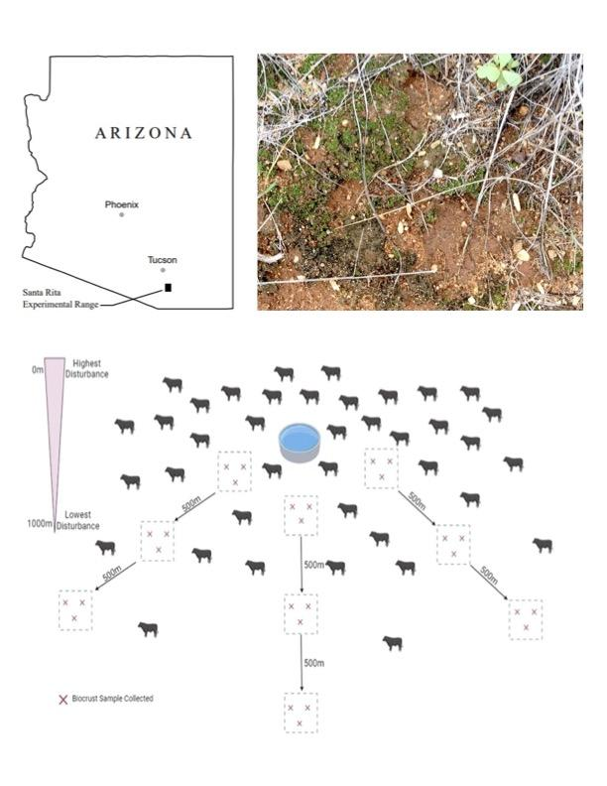**Figure 1.1. Study location, representative biocrust, and experimental design.** Upper left, study location in the state of Arizona, showing the Santa Rita Experimental Range (SRER). Upper right, representative soil crust, showing dark black-green cyanobacteria and cyanolichens, and bright green mosses, as well as damage to the area from trampling by cattle (left-center of image). Bottom, schematic of sampling design for the survey of fungi associated with biological soil crusts at SRER. Each red “x” represents a collected biocrust sample, arrows represent transects, and dotted squares represent plots. Density of cattle is represented by the small icons. The upper left shows the expected gradient from highest to lowest disturbance. The experimental design was replicated in three pastures.

**Figure 1.2. Phylogenetic diversity of biocrust fungi from SRER** (grey bars in the colored ring) within the Ascomycota, with colors indicating fungal classes. The tree was inferred via maximum likelihood with the Evolutionary Placement Algorithm in TBAS (Carbone, 2019). The most common classes of fungi in biocrusts were Pezizomycetes (pink), Sordariomycetes (red), Lecanoromycetes (purple), Eurotiomycetes (dark red), and Dothideomycetes (lime green), with additional representation by the Leotiomycete and Arthoniomycetes.

**Figure 1.3. Richness and diversity of biocrust fungi in each focal pasture at SRER**, observed via Illumina sequencing, as a function of distance from water tanks. Upper panel: there is a strong trend whereby richness varied as a function of distance to the water tank when pasture was included in models as a random factor (ANOVA, F(2,135) = 2.5539, R2 = 0.04, P = 0.075). Richness generally decreased as a function of distance from the tanks (i.e., as disturbance decreased) across the data set as a whole, even though within-pasture analyses were not significant (results of ANOVA, pastures 5N, 5S, and 6B: P = 0.2528, 0.5671, and 0.1644, respectively). Lower panel: Diversity did not vary meaningfully as a function of distance when pasture was included in models as a random factor (F(2,135) = 0.4463, R2 = 0.00751, P = 0.706).

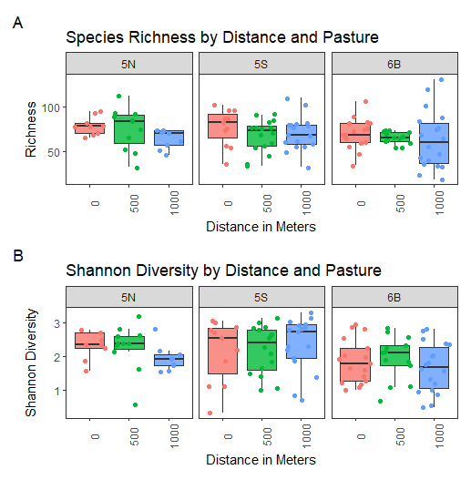

**Figure 1.4. Community composition of fungi from biocrusts at SRER differed as a function of distance to water tanks.** Upper panel, composition of fungal communities was compared via Bray-Curtis distance and ordinated via non-metric multidimensional scaling (NMDS). Communities differed significantly as a function of disturbance from water tanks and among pastures (PERMANOVA, considering distance and pasture: P<0.001; stress = 0.24).Lower panels: individually each pasture contained significant differences in community composition by distance except 5N (PERMANOVA; 5N, P = 0.1540, stress = 0.20; 5S, P<0.0010, stress = 0.19; 6B, P = 0.0126, stress = 0.23).

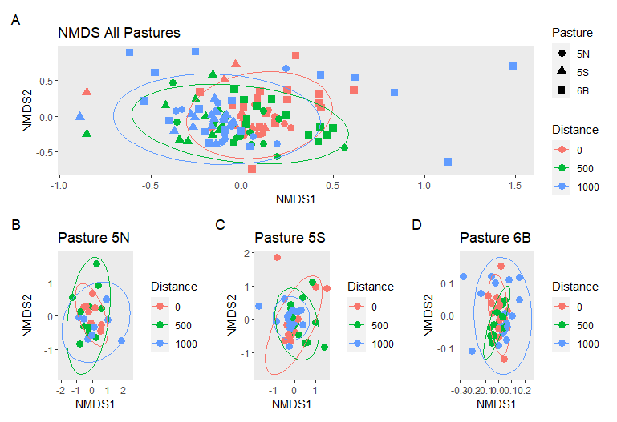

**Figure 1.5. Fungal communities identified from different substrates in the same area differed among substrate types.** Composition of fungal communities from biocrusts, bulk soil, leaf litter, rhizosphere soil from common plants in the area, and roots of those plants, was assessed using the same methods, compared via Bray-Curtis distance and ordinated via non-metric multidimensional scaling (NMDS). Fungal communities from biocrusts, soil, leaf litter, rhizosphere soil, and roots differed significantly in composition (PERMANOVA, P<0.001, stress = 0.24). Especially strong differences were observed between biocrust fungi and fungi inhabiting roots, rhizosphere soil, and bulk soil, pointing to a distinctive community in the photosynthetic biocrusts that, in turn, shares species with those that occur in above-ground plant tissues (here represented by leaf litter).

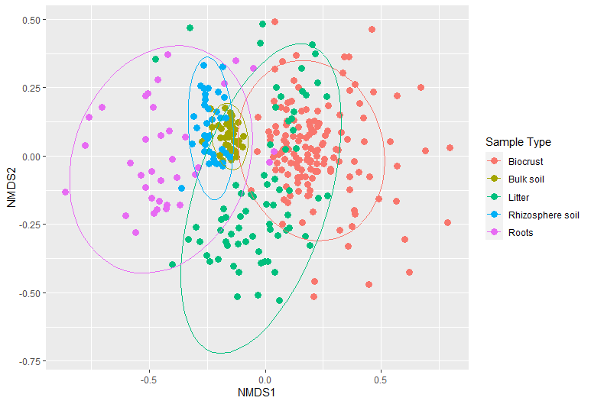

**Figure 1.6. Ecological functions of fungi in biocrusts differ as a function of distance from tanks.** Evaluation of indicator species via FUNGuild (Nguyen et al., 2016) and through literature review reveals putative ecological function of representative fungi from the areas of least disturbance (1000m from tanks) and highest disturbance (nearest to tanks). Overall, areas near tanks had a markedly higher prevalence of pathogens of animals and a decrease in lichenized and lichen-associated fungi relative to areas far from tanks.

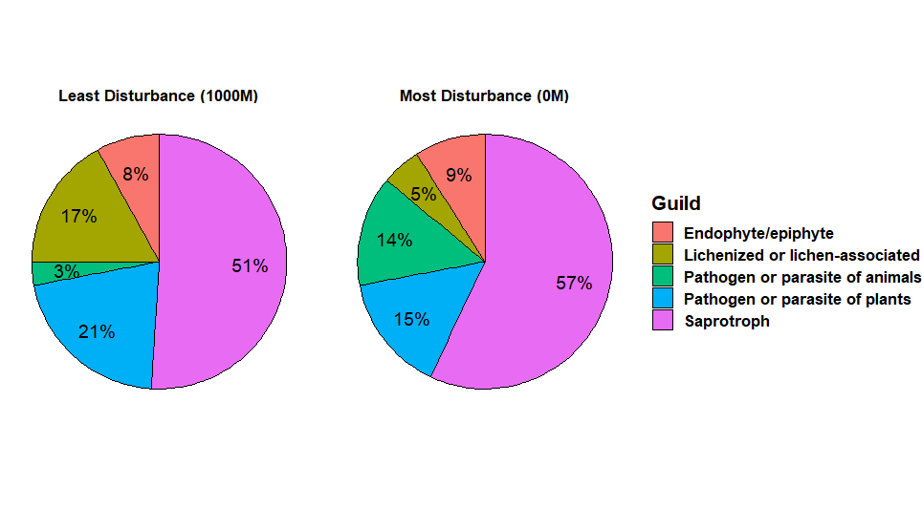

**Figure 1.7. Although ecological functions differed as a function of distance to tanks, the prevalence of major fungal lineages did not.** Taxonomic assignments are based on OTUs clustered by 95% similarity identified using TBAS Pezizomycota 2.1 database for Ascomycota (Carbone et al., 2019) and here are depicted for areas farthest from tanks (1000m) and nearest to tanks. In general the prevalent classes are represented in similar relative abundances in both settings, though two additional classes were found at the 1000m sites. Overall we conclude that distance from the tanks, and by proxy, disturbance due to cattle, was not associated with a major shift in phylogenetic composition, but instead, shifts in species composition and function.

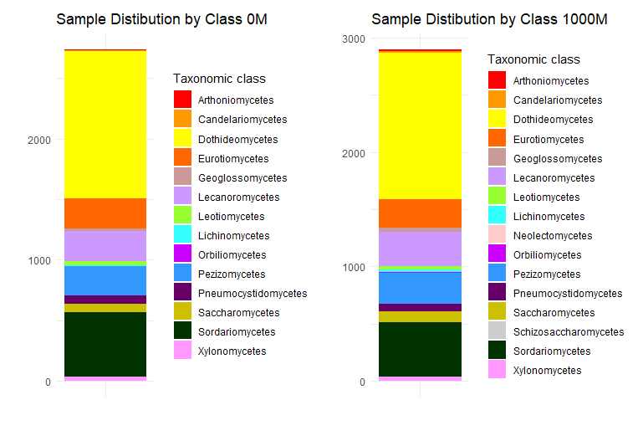

**CHAPTER TWO**

**IDENTIFICATION OF FUNGAL SYMBIONTS OF LEAVES AND LICHENS FROM ARID AND SEMI-ARID AREAS OF SOUTHWEST AFRICA, AND THEIR PLACEMENT IN A THREE-CONTINENT CONTEXT**

Mariam Hosseini Marand and A. Elizabeth Arnold

**ABSTRACT**

Endophytic fungi are microorganisms that colonize the interior of vascular plants, bryophytes, and lichens without causing symptoms. Plants in arid environments may particularly benefit from their associations with endophytic fungi, as these symbionts can alleviate the impacts of drought stress, heat stress, nutrient-limited soils, ultraviolet radiation, and high salinity. While endophytes in arid environments are known to be species rich and represent a high degree of phylogenetic diversity, limited work has been done to assess how they differ spatially or geographically, nor how endophyte communities may vary with regard to climate factors that are important in shaping arid lands. With a focus on culturable foliar endophytes derived from plants and lichens, the purpose of this study was to 1) characterize the fungal communities cultured from plants and lichen collected in arid sites in Namibia and South Africa; 2) assess how these fungal communities differ with previously collected endophytes from arid sites in Arizona and Chile; and 3) determine how endophyte richness and composition may scale with climatic factors such as mean annual temperature, mean annual precipitation, precipitation in the wettest quarter, and precipitation in the driest quarter. Consistent with previous studies, we found that endophytes from southern Africa are phylogenetically diverse. They represent abundances at the class level that resemble endophytes from other arid lands. However, African endophytes are distinct from those in Chile and Arizona at the species level. Species richness varied positively with precipitation, suggesting an important role of rainfall in promoting endophyte diversity. Understanding how endophyte communities differ in their richness and composition within arid environments at different spatial locations and the climatic factors that drive these differences has important implications for predicting how plant-fungal symbioses may shift in relation to climate change, particularly in arid environments which become hotter and dryer every year.

**INTRODUCTION**

Fungal diversity is exceptional, comprising millions of species [(Hawksworth & Lücking, 2017)](https://www.zotero.org/google-docs/?tybHrz). Only a subset of fungal species have been described – on the order of 150,000 species – leaving a plethora of fungal diversity that is yet to be explored [(Gautam et al., 2022; Lücking et al., 2021)](https://www.zotero.org/google-docs/?neGWdH). Fungal diversity can be apparent in their distinct morphologies, diverse metabolites, vast ecological functions, and wide range of habitats, all of which underlie the traditional science of mycology and the subdiscipline of fungal systematics. However, in the past 40 years, and especially in the past decade, massive advances in sequencing technology and decreased costs associated with sequencing have exponentially enabled the characterization of fungal diversity at a previously unimagined scale [(Priest et al., 2020)](https://www.zotero.org/google-docs/?8qRz4R). As a result, since 2010 the rate of new species described has averaged around 1,800 per year, which is largely attributed to such advances[(Hawksworth & Lücking, 2017)](https://www.zotero.org/google-docs/?wGCaXm) and has revolutionized fungal taxonomy.

The methods used to uncover fungal taxonomy can differ depending on whether the fungi is cultured or assessed *in situ* and from there how identification occurs through sequence based DNA-barcoding and phylogenetic reconstruction [(Lücking et al., 2021)](https://www.zotero.org/google-docs/?RSilb5). Genetic markers such as the nuclear internal transcribed spacer (ITS) region of the ribosomal RNA operon have become the barcoding standard in mycology [(Lücking et al., 2021; Schoch et al., 2012)](https://www.zotero.org/google-docs/?FKmPbO). While high throughput and next generation sequencing for fungi *in situ* has great value in characterizing unculturable fungi and uncovering missing species [(Gautam et al., 2022)](https://www.zotero.org/google-docs/?dXslVt), generating fungal cultures and storing them as vouchers is crucial for documenting and expanding our knowledge of fungal diversity. Together, vouchers and metadata allow researchers to validate the identification of taxa, provide information on the location and host range or substrate use of the fungi, provide a timescale of organisms’ presence or activity in an environment, and provide researchers with a specimen for use in future research, -omics analysis, and experiments [(Culley, 2013)](https://www.zotero.org/google-docs/?63AXm7). Sanger sequencing is commonly used to uncover DNA sequences in culturable fungi as it can be used to generate relatively long reads of diagnostic loci for individual specimens [(Gautam et al., 2022)](https://www.zotero.org/google-docs/?3JRpMq). More broadly, Sanger sequencing coupled with culturing in little-known substrates or regions holds promise for uncovering the scope of biodiversity of fungi and understanding their place in the tree of life. This perspective motivates this chapter, where I focus on endophytic fungi that occur within plants in arid regions of the world.

*Plant symbiosis and fungal endophyte diversity*

Plants and fungi have a long history of symbiotic relationships beginning with Glomeromycota as an arbuscular mycorrhizal symbiont of embryophytes over 200 million years ago (mya[)](https://www.zotero.org/google-docs/?PToYe4)(Lutzoni et al. 2018). Plant-fungal symbioses are thought to have allowed for the colonization of land by plants [(Berbee et al., 2017; Delaux et al., 2015)](https://www.zotero.org/google-docs/?Vhhpr4) and remain vital to functional aspects of plants today, including as mycorrhizae in roots, and endophytes in roots, stems, and photosynthetic organs. I am especially motivated to study endophytes associated with photosynthetic tissues (hereafter, foliar endophytes or endophytes), because they are phylogenetically diverse, often horizontally transmitted fungi that occur in the light-harvesting organs of plants without causing disease.

Endophytes that occur in the photosynthetic tissues of plants primarily belong to the phylum Ascomycota [(Arnold, 2007)](https://www.zotero.org/google-docs/?NBrxbY). Having evolved closely with land plants, foliar endophytes can be found across all plant lineages in every biome [(Apigo & Oono, 2018; Arnold & Lutzoni, 2007)](https://www.zotero.org/google-docs/?broken=uMCNJ1). They comprise a tremendous diversity of species, including in arid locations. For example, [Massimo et al. (2015](https://www.zotero.org/google-docs/?CfaCnK)) highlighted their diversity in plants of the Sonoran Desert in southwestern North America. In that study, the authors showed that diverse endophytes occur in leaves and stems of desert plants, and that community composition differed based on host species and location. Similarly, [Arnold and Lutzoni (2007](https://www.zotero.org/google-docs/?oWSSht)) examined endophyte communities across a broad latitudinal gradient. They showed that endophytes are common in plants in the tropics, but also that they occur frequently in plants in arid landscapes, including hot deserts and polar deserts (e.g., Arctic tundra). In that study, distinctive fungi were found in different biomes, suggesting that those in any given plant community or environment may be markedly different from those in different plant communities or environments.

In addition to diversity as a function of biogeography at a global and regional scale, endophyte diversity can be observed even among the same plant species. For example, Silva-Hughes et al. (2015) characterized 17 different species of endophytic fungi from the desert native cactus *Opuntia humifusa* alone. Arnold and Lutzoni (2007) reported dozens to hundreds of species of endophytes in individual hosts within their study sites, a perspective echoed by recent work led by U’Ren et al. (2019). Oono et al. (2014) showed that complex population genetics may distinguish endophytes associated with different hosts in the same environment, and may represent cryptic diversity among endophytes in a given host. In turn, Arnold et al. (2003) showed that endophyte communities may differ in a single species of tropical tree across the landscape, with near total turnover in endophyte communities when host individuals were in areas approximately 60 km away from each other.

While several studies have highlighted endophyte biodiversity within arid-land plants (eg. [Massimo et al., 2015; Rodriguez et al., 2009; Silva-Hughes et al., 2015; Zuo et al., 2021)](https://www.zotero.org/google-docs/?1gcs6G) , no such study has yet assessed how this diversity translates across arid ecosystems globally. This chapter includes new data from endophytic fungi associated with photosynthetic hosts in southern Africa, and compares them with the endophytes found in previous studies in southwestern South America (Chile) and the southwestern US (Arizona), and places them into a framework based on climate variables.

*Effects of climate and plant-endophyte symbiosis*

Climate change due to increases in atmospheric CO2 and other greenhouse gasses is anticipated to lead to shifts in the interactions between plants and the diverse organisms that affiliate with them [(Compant et al., 2010; Duarte & Maherali, 2022; Slaughter et al., 2018)](https://www.zotero.org/google-docs/?T8wx7V). These changes include interactions between plants and macroscopic mutualists: for example, shifts in the seasonality of plant phenology due to climate change have had detrimental effects on partnerships with pollinators, which can lead to coextinction [(Bascompte et al., 2019)](https://www.zotero.org/google-docs/?IlLtSN). The majority of studies that have examined the effects of climate change on plant-fungal mutualism have focused on domesticated plant species rather than wild plants [(Duarte & Maherali, 2022)](https://www.zotero.org/google-docs/?broken=vzh9vP), but both wild and domesticated plants are key elements of the ecosystems on which humans depend. Although increases in temperature have not directly been linked to losses in endophyte diversity, losses in plant biodiversity impacted by global warming may consequentially lead to losses in diversity of specialized endophytic communities [(Compant et al., 2010)](https://www.zotero.org/google-docs/?MeBDaq). In turn, other plant-fungal symbioses may actually be strengthened by climate change: for instance, arbuscular mycorrhizal fungi, which play important roles in nutrient uptake by plants, are not as cold tolerant as other fungal groups. Thus, localized warming could increase their range, and rising CO2 levels may reduce the carbon cost to plants for supporting their fungal partners [(Duarte & Maherali, 2022)](https://www.zotero.org/google-docs/?BXuBIW). Rising CO2 levels may support symbiosis in certain endophytic fungi as well: for instance, *Epichlöe* infection rates are higher in tall fescue grasses when CO2 levels are elevated (Brosi et. al 2009). Climate change can also contribute to a higher colonization rate of fungal endophytes that produce toxic compounds, but simultaneously reduce the quantity of toxic compounds they produce [(Compant et al., 2010)](https://www.zotero.org/google-docs/?GQxn8D), including ergovaline and loline produced by *Neotyphodium* (Brosi et al., 2009). More generally, it is likely that some fungal endophytes and their host plants will shift in their geographic distributions as their optimal climate conditions are lost, but understanding this requires a fundamental knowledge of where fungi are distributed today. This knowledge is lacking in most environments.

The aim of this chapter is to highlight a new data set generated during my thesis work on endophytes that were isolated in culture from living photosynthetic tissues of wild hosts in arid and semi-arid regions of southern Africa (South Africa, Namibia). Briefly, we generated barcode sequences for 441 isolates that were not previously characterized. Then, we compared those endophyte communities to data obtained from similar culturing efforts in arid areas of South America (Chile, Atacama Desert) and the Sonoran Desert of southwestern North America. We place endophyte richness in a climate-centered context by examining its relationship to climate variables such as mean annual temperature, mean annual precipitation, and mean precipitation during the wettest and driest quarters, with a wide range of conditions encompassed by our data set across drylands on three continents.

**METHODS**

In late fall 2019, plant and lichen samples were collected at sites across Namibia and South Africa for endophyte isolation (Figure 2.1). These sites are listed in Supplementary Table 2.1. The collection locations included the Namib Desert and inland plateau of Namibia, and West Coast National Park, the Little Karoo, Namaqua National Park, and the savanna of northeastern South Africa. These sites encompass distinctive plants and lichens and a wide range of climate variables (Supplementary Table 2.1). In each collection site, fresh tissue of locally representative plants and lichens were collected and processed for endophyte isolation within 48 hours. Up to 10 plant species and 10 lichen species were collected fresh in each site. Hosts were identified to species and recorded. Similar work was completed in 2018 in Chile and in 2005-2020 in Arizona, with details of sites and collections in Supplementary Table 2.2 and Supplementary Table 2.3, respectively.

*Endophyte isolation*

Photosynthetic tissue samples were cut into approximately 1-2mm pieces and surface-sterilized via manual rinsing in tap water, 95% ETOH for 10s, 0.5%NaOCl for 2 minutes, and 70% ETOH for 2 minutes [(Massimo et al. 2015)](https://www.zotero.org/google-docs/?broken=G5ASsH). Individual tissue pieces were placed under sterile conditions into 1.5ul tubes containing autoclaved 2% malt extract agar, a standard medium that promotes growth by diverse fungi (Arnold & Lutzoni, 2007, Massimo et al., 2015, U’Ren et al., 2019, Oita et al., 2021a). Tubes were incubated at room temperature (21.5°C) and endophytic fungi emerged from tissue samples over the course of 2019-2022. Tubes with fungal growth were enumerated in 2022 and processed for Sanger sequencing as described below. All strains are retained at the University of Arizona as vouchers for future work.

*Molecular analysis*

Total genomic DNA was extracted from each fungal isolate with the RedExtract-N-Amp plant PCR kit (Sigma-Aldrich, St. Louis, Missouri, USA) (Oita et al., 2021). We used the polymerase chain reaction (PCR) to amplify the nuclear ribosomal internal transcribed spacer region (ITS) and 5.8S gene, with primers ITS1F and LR3 (see [Higgins et al., 2014)](https://www.zotero.org/google-docs/?aIUHbn). PCR recipes and cycling parameters followed Higgins et al. (2014) and Oita et al. (2021a). Amplification of the target region (ca. 1000-1200 basepairs) was confirmed via gel electrophoresis. If the first round of PCR was unsuccessful, we repeated PCR with ITS5 and ITS4 or ITS1W and ITS4, or conducted a nested PCR using ITS5 and ITS4 [(Francois, Lutzoni, 2001)](https://www.zotero.org/google-docs/?QLXL4r). Samples that were amplified successfully were then cleaned using ExoSAP-IT (Affymetrix, USA) per the manufacturer’s instructions, and sent to the University of Arizona Genetics Core for bidirectional sequencing with the same primer set on the Sanger platform.

Sequences were assembled, trimmed and assigned per-nucleotide quality scores with *phred* and *phrap,*[(Ewing & Green, 1998)](https://www.zotero.org/google-docs/?BTArMJ)orchestrated by Mesquite (Maddison and Maddison, 2008). We manually checked the quality of each base call in Sequencher V5.1 (Sequencher, 2012) and edited according to chromatograms when needed. After editing, the total southern Africa dataset contained 448 sequences (Supplementary Table 2.1). Sequences were obtained for 102 samples from Chile (Supplementary Table 2.2) from work completed by Shuzo Oita (unpublished) and from 4278 samples from Arizona (Supplementary Table 2.3) from work completed by Yu-Ling Huang, Gavin Lehr, Nicolas Massimo, MM Nandi Devan, Dustin Sandberg, Nick Garber, and Elizabeth Bowman (Massimo et al., 2015, Sandberg et al., 2014, Lehr, 2018, Huang et al., 2018, Bowman and Arnold, 2018, Arnold et al., unpublished).

Edited sequences were uploaded to TBAS v2.0 (Carbone et. al., 2019) in order to assign operational taxonomic units by clustering sequences on the basis of 95% sequence similarity. (Supplementary Table 2.7). The samples from Africa were analyzed in one run, and the full data set including data from Chile and Arizona was analyzed in a second run.

Representative sequences for each OTU were placed phylogenetically by TBAS (Carbone et. al., 2019). Placement was accomplished with maximum likelihood under the evolutionary placement algorithm with the pezizo_v2_1 reference set and default parameters (Carbone et al., 2019).

*Statistical analyses*

Historical climatic data were downloaded from WorldClim2 database [(Fick & Hijmans, 2017)](https://www.zotero.org/google-docs/?broken=VAaii6) for each sampling site and location. Data for mean annual temperature, mean annual precipitation, mean precipitation in the driest quarter, and mean precipitation in the wettest quarter were extracted from the database using RStudio (RStudio Team, 2020) and GPS coordinates as detailed in Supplementary table 2.6. The associations among co-varying climatic variables were characterized by a correlation matrix based on Pearson coefficients. Once correlations were confirmed a principal components analysis was used to generate composite variables for climate, defined as the two axes (PC1, PC2) that together explained the majority of climate variation among sites.

Species richness was estimated as the number of OTUs in a given sample. Richness values were ln-transformed to approximate normality prior to analysis as detailed in Supplementary Table 2.6. We used an analysis of variance (ANOVA) to evaluate variation in endophyte richness among sampling areas. We evaluated the relationship of ln-transformed richness to PCI and PC2 via multiple regression.

Differences in community composition were generated evaluated via Bray-Curtis dissimilarity values, which were calculated in RStudio package *vegan* (Jari et.al, 2022). Non-metric multidimensional scaling (NMDS) plots were generated to visualize community composition differences among study areas. Their significance was analyzed via permutational analysis of variance (PERMANOVA) with study region as a main effect.

Taxonomy was assigned based on placement in TBAS. Class-level identification in the Ascomycota was compared among study regions. Results we used *ggplot2*  (Wickham, 2016)to visualize these data in RStudio (RStudio Team, 2020).

**RESULTS AND DISCUSSION**

Endophytes cultured from plant and lichen samples from southern Africa represented diverse fungi (Figure 2.2). From 441 cultured samples across 6 collection sites 131 unique operational taxonomic units (OTUs) were obtained (Supplementary Table 2.4). Endophytes represented five classes, with the majority of endophytes belonging to Dothideomycetes, Sordariomycetes and Pezizomycetes. These results were then compared across all three regions for which 371 OTUs (Supplementary Table 2.5) were represented across nine classes of Ascomycota (Figure 2.2).

We observed a strong trend suggesting variation among the three sampling regions (ANOVA, F (2,34) = 2.828, P = 0.0731). Host type from which the endophytes were isolated did not have a significant impact on species richness at the large geographic scale of this study (F (3, 33) = 0.3423, P = 0 .7949), such that we did not consider it in further analyses. These results were consistent with previous studies such as that by [Giauque and Hawkes (2013](https://www.zotero.org/google-docs/?broken=YsRL80)), which showed using historical data on grass endophytes that precipitation was the most important predictor of endophytic communities and that there was no significant impact of host type.

We thereafter examined the relevance of climate factors by first considering correlations among measures such as mean annual temperature, mean annual precipitation, and mean precipitation in the driest and wettest quarters (Figure 2.3). Strong correlations led us to generate composite variables that captured these four factors in two dimensions (PC1 and PC2 from a principal components analysis) (Figure 2.4). PC1 explained 66% of the variance in these measures of climate. Its positive values are associated with wetter climates, and its lower values are associated with drier climates. PC2 explained 18% of variation in these climate measures; its higher values generally indicate warmer climates, and lower values are associated with cooler climates.

Species richness was strongly related to climate (whole model, multiple regression: R2 = 0.23, F (2,34) = 4.9946, P = 0.0125). Richness varied significantly and positively with PC1 (capturing precipitation) (F (1, 35) = 9.692, P = 0.0037), but not with PC2 (capturing temperature) (F (1,35) = 0.297, P = 0.5892). Accordingly, we did not observe strong relationships between richness and mean annual temperature (F (1, 35) = 0.7717, p= 0.3857) or mean precipitation in the wettest quarter (F( 1, 35) = 2.659, p = 0.1119), but mean annual precipitation (R2 = 0.33, F (1, 35) = 11.78, P = 0.0016), and mean precipitation in the driest quarter (R2 = 0.25, F (1, 35) = 17.01, P = 0.0002) were significant. Strong relationships have been observed previously between factors such as precipitation and seasonality and endophyte richness (e.g., Oita et al., 2021b; see also Arnold 2022, Arnold & Herre 2003, [Giauque & Hawkes 2013](https://www.zotero.org/google-docs/?broken=7jactK)). Generally, higher rainfall and associated humidity may open stomata, promote more active spore germination, and support more fungi in the environment, important during the horizontal transmission phase for endophytes of plants and lichens.

*Community composition*

Endophyte communities significantly differed in their composition across arid regions on three continents (Figure 2.5) (PERMANOVA, F = 2.3187, P = 0.0004, stress= 0.18). Such differences among distant locations align with previous studies (see Arnold & Lutzoni, 2007, U’Ren et al., 2012, U’Ren et al., 2019) and are here shown for arid lands for the first time. Given that endophyte diversity is generally lower in drylands than in wetter locations (Arnold et al. 2009), this study confirms that they do not represent a few species that have survived in widespread arid regions around the world, but distinctive species assemblages that likely reflect the biogeographic history and local diversification of fungi in each region (see U’Ren et al., 2019). This aligns with the long history of geographic separation of arid lands on the three continents considered here.

Given that there is a long history of separation among regions, and the presence of different host species in each region, it is plausible that different major lineages (classes) of fungi would be found in each arid region considered here. However, we found no meaningful differences in the relative abundance of fungal classes among our study regions (Figure 2.6). Overall locations contained a similar proportion of Dothideomycetes, which was the dominant class across all regions studied here. Dothideomycetes often are detected as endophytes of desert plants (e.g., Massimo et al., 2015; Sandberg et al., 2022), where their often-melanized structures are thought to provide protection from solar radiation and desiccation. Sordariomycetes were the next most common class, found in a high abundance and in similar proportions across all regions. The remaining classes were found at more variable abundances, including a relative prevalence of Pezizomycetes in Chile and southern Africa, and a relative prevalence of Leotiomcyetes in Arizona. The prevalence of Pezizomycetes in the global south is compelling given recent studies on that group (Healey et al. 2022), whereas the abundance of Leotiomycetes in Arizona may reflect our inclusion of montane dryland systems in local sampling (see results of Huang et al., 2018, Bowman and Arnold, 2021). Thus, overall, differences in endophyte assemblages among arid regions reflects differences in species composition of endophytes, rather than deep phylogenetic differences, in alignment with global observations of the particular prevalence of Dothideomycetes, Sordariomycetes, Pezizomycetes, and Leotiomycetes as four of the five most common classes of endophytes worldwide (Arnold, 2007, Arnold et al., 2009, U’Ren et al. 2019, Oita et al. 2021a, 2021b).

Overall this study highlights the richness and distinctiveness of fungal endophytes in arid environments on three continents. We show that precipitation, rather than temperature, is strongly associated with their richness. Communities of endophytes in these regions appear to be relatively thermotolerant, but they may be less resistant to changes in precipitation due to climate change. The importance of both total precipitation (mean annual precipitation) and seasonal drought (mean precipitation in the driest quarter) suggests that increased aridification, especially through increases in seasonal drought, may be particularly important in defining the future of dryland endophytic symbionts in a changing world.

Findings of this study are preliminary, in that they do not include endophytes from more mesic areas in each study zone. Our study also is based upon culturable endophytes, which likely represent only a subset of the total diversity of endophytes present in each site (see U’Ren et al., 2019, Oita et al., 2021, Gautam et al., 2022). Pairing these findings with a culture-free sequencing approach such as the Illumina platform could complement our findings. We note that the relatively low isolation frequency in arid lands may also argue for a metabarcoding approach, as processing large numbers of tissue samples that yield cultivable endophytes infrequently is time-intensive. However, even if culturing does not capture the same species richness as Illumina-based metabarcoding, major ecological trends often are captured from culture-based studies (e.g., Arnold & Lutzoni, 2007, Arnold et al., 2009, U’Ren et al., 2012, Massimo et al., 2015, Bowman & Arnold 2018, Oita et al., 2021a). Moreover, most amplicon metabarcoding studies use only a single primer pair, such as ITS1F and ITS5. In the present study, we occasionally needed to use alternative primers to successfully amplify focal strains. Thus, it is possible that metabarcoding studies could be improved by using multiple primer pairs in parallel.

Ultimately, by culturing from host material in only six sites in southern Africa, we were able to add over 370 distinctive genotypes to our living voucher collection. Further analyses will compare these arid-land endophytes to those in more mesic sites on the same continents, providing a broader understanding of the distribution of fungi that affiliate with photosynthetic hosts, and how they may be sensitive to our changing climate.

**ACKNOWLEDGEMENTS**

We thank the governments, land managers, and peoples of Namibia, South Africa, and Chile for the opportunity to conduct research there. We thank Shuzo Oita for generating DNA sequences from the fungi isolated in Chile. We are grateful for plant records, original cultures, field records, and metadata generated by Shuzo Oita, Alicia Ibáñez, François Lutzoni, Jolanta Miadlikowska, Nathaniel Yang, and Ian Medeiros, with Reinaldo Vargas (Chile), Terry Hedderson (South Africa), and Gillian Maggs-Kölling (Namibia). For sequence data, plant records, field records, and metadata generated in Arizona we acknowledge work by Yu-Ling Huang, Gavin Lehr, Nicolas Massimo, MM Nandi Devan, Dustin Sandberg, Elizabeth Bowman, and Nick Garber, as well as additional student assistants. For funding we thank the School of Plant Sciences and the College of Agriculture, Life and Environmental Sciences at the University of Arizona and the National Science Foundation (DEB-154149 to AEA). Additional support was provided by United States Department of Agriculture - National Institute of Food and Agriculture (USDA NIFA) awards to AEA and colleagues for research regarding arid-land microbiomes (ARZT-1361340-H25-242) and to AEA for support of the Robert L. Gilbertson Mycological Herbarium (ARZT-1259370-S25-200).

**Figure 2.1: Locations of arid environments studied.** World map highlighting the locations where sampling occurred as a part of NSF funded Genealogy of Life project, including Chile and Southern Africa (Namibia and South Africa), as well as the study region in North America (Arizona). Regions were selected for being dryland environments with distinctly different geographies.

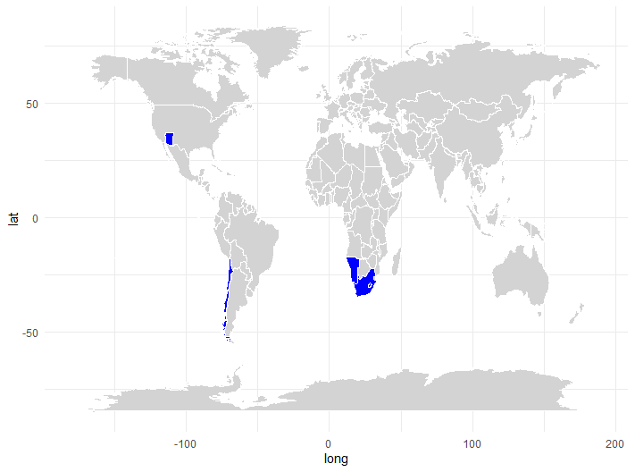

**Figure 2.2: Phylogenetic diversity of fungi isolated from plant and lichen samples in dryland environments.** The inner ring represents classes of Ascomycota, the middle ring represents plant or lichen hosts, and the outermost ring represents the region of study. Across all sites, dryland endophytes were predominantly members of Dothideomycetes (burgundy), followed in prevalence by Sordariomycetes (light blue), then Pezizomycetes (dark-blue). Leotiomycetes (red) and Eurotiomycetes (purple) were also found.

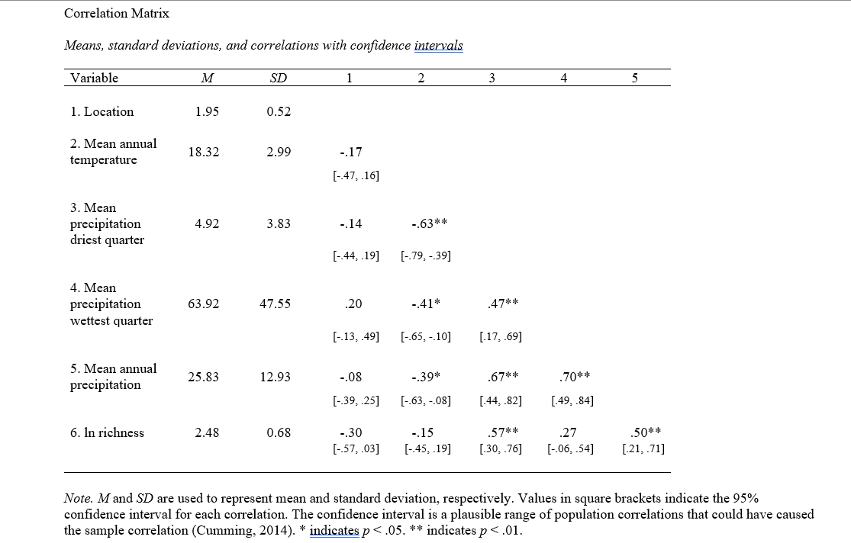**Figure 2.3: Pearson correlation coefficients to assess relationships among climatic factors.** Positive significant values indicate positive associations; negative significant values indicate an inverse correlation. When looking at climatic variables each pair is significantly correlated with one another and therefore must be analyzed as interacting variables.

**Figure 2.4: PCA plot mapping climatic factors and their composite correlations with one another.** Blue arrows represent climatic factors and their relation to calculated principal components. Colored dots represent collection sites with differing climatic conditions from three arid regions: Arizona, Chile, and Southern Africa. PC1 explained 66% of the variance and its positive values are associated with wetter climates. PC2 explained 18% of variation and its positive values are associated with warmer temperatures. Thus, the upper left is hottest and driest, the lower right wettest and coolest.

**Figure 2.5: Endophyte community composition differ among dryland environments on three continents.** Bray-Curtis distances were ordinated via non-metric multidimensional scaling (NMDS). Each point represents an endophyte community in a given site, colored by the region of collection. Endophyte communities significantly differed in their composition when comparing across arid locations globally (PERMANOVA, F = 2.3187, P = 0.0004, stress = 0.18) indicating arid land endophytes differ in their composition at the OTU level.

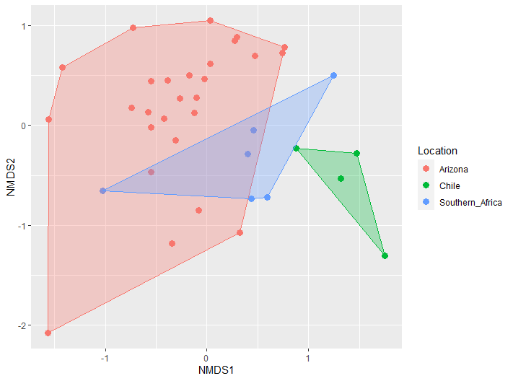

**Figure 2.6: Distribution of fungal classes in Ascomycota across three dryland environments.** Taxonomic assignments are based on OTU sequences clustered by 95% similarity and identified using TBAS (Pezizo_V2.1 database; Carbone et al., 2019). Proportions reflect the number of endophyte samples identified to each class within each arid region (Southern Africa, Arizona, and Chile). Overall arid lands were dominated by Dothideomycetes followed by Sordariomycetes and from there minor class distributions were varied by location.

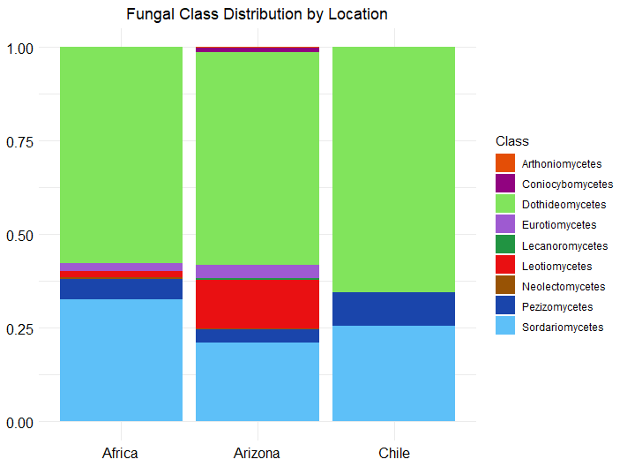

**REFERENCES**

.

[Ali, A. H., Abdelrahman, M., Radwan, U., El-Zayat, S., & El-Sayed, M. A. (2018). Effect of Thermomyces fungal endophyte isolated from extreme hot desert-adapted plant on heat stress tolerance of cucumber. *Applied Soil Ecology*, *124*, 155–162. https://doi.org/10.1016/j.apsoil.2017.11.004](https://www.zotero.org/google-docs/?Jaiazr)

[Ali, A. H., Radwan, U., El-Zayat, S., & El-Sayed, M. A. (n.d.). *Desert Plant-Fungal Endophytic Association: The Beneficial Aspects to their Hosts*.](https://www.zotero.org/google-docs/?230WOB)

Andrews, S. (2010). FastQC: A Quality Control Tool for High Throughput Sequence Data [Online]. Available online at: http://www.bioinformatics.babraham.ac.uk/projects/fastqc/

<https://doi.org/10.1007/s00425-018-2982-y>

[Archer, S. R., & Predick, K. I. (2008). Climate Change and Ecosystems of the Southwestern United States. *Rangelands*, *30*(3), 23–28. https://doi.org/10.2111/1551-501X(2008)30[23:CCAEOT]2.0.CO;2](https://www.zotero.org/google-docs/?rP3j2N)

[Arnold, A. E. (2007). Understanding the diversity of foliar endophytic fungi: Progress, challenges, and frontiers. *Fungal Biology Reviews*, *21*(2–3), 51–66. https://doi.org/10.1016/j.fbr.2007.05.003](https://www.zotero.org/google-docs/?CDdLrf)

[Arnold, A. E., & Lutzoni, F. (2007). Diversity and host range of foliar fungal endophytes: Are tropical leaves biodiversity hotspots? *Ecology*, *88*(3), 541–549. https://doi.org/10.1890/05-1459](https://www.zotero.org/google-docs/?h7BI0j)

[Arnold, A. E., Mejía, L. C., Kyllo, D., Rojas, E. I., Maynard, Z., Robbins, N., & Herre, E. A. (2003). Fungal endophytes limit pathogen damage in a tropical tree. *Proceedings of the National Academy of Sciences of the United States of America*, *100*(26), 15649–15654. https://doi.org/10.1073/pnas.2533483100](https://www.zotero.org/google-docs/?DDZ2us)

[Bascompte, J., García, M. B., Ortega, R., Rezende, E. L., & Pironon, S. (2019). Mutualistic interactions reshuffle the effects of climate change on plants across the tree of life. *Science Advances*, *5*(5), eaav2539. https://doi.org/10.1126/sciadv.aav2539](https://www.zotero.org/google-docs/?OQC5nM)

[Bates, S. T., Nash, T. H., & Garcia-Pichel, F. (2012). Patterns of diversity for fungal assemblages of biological soil crusts from the southwestern United States. *Mycologia*, *104*(2), 353–361. https://doi.org/10.3852/11-232](https://www.zotero.org/google-docs/?J8FVk8)

[Belnap, J. (1995). Surface disturbances: Their role in accelerating desertification. *Environmental Monitoring and Assessment*, *37*(1), 39–57. https://doi.org/10.1007/BF00546879](https://www.zotero.org/google-docs/?o59mdi)

[Belnap, J., & Lange, O. L. (Eds.). (2003). *Biological Soil Crusts: Structure, Function, and Management* (Vol. 150). Springer Berlin Heidelberg. https://doi.org/10.1007/978-3-642-56475-8](https://www.zotero.org/google-docs/?pkb6eB)

[Berbee, M. L., James, T. Y., & Strullu-Derrien, C. (2017). Early Diverging Fungi: Diversity and Impact at the Dawn of Terrestrial Life. *Annual Review of Microbiology*, *71*(1), 41–60. https://doi.org/10.1146/annurev-micro-030117-020324](https://www.zotero.org/google-docs/?Go2OVQ)

[Bowker, M. A., Doherty, K. D., Antoninka, A. J., Ramsey, P. W., DuPre, M. E., & Durham, R. A. (2022). Biocrusts Influence Vascular Plant Community Development, Promoting Native Plant Dominance. *Frontiers in Ecology and Evolution*, *10*, 840324. https://doi.org/10.3389/fevo.2022.840324](https://www.zotero.org/google-docs/?HePNnx)

Brosi GB Nelson JA McCulley RL Classen AT Norby R (2009) *PS 45–40:* Global change factors interact with fungal endophyte symbiosis to determine tall fescue litter chemistry. The 94th ESA Annual Meeting, PS5–40.

Büdel B, Lange OL (1994) The role of cortical and epinecral layers in the lichen genus Peltula. Cryptogam Bot 4:262–269 <https://doi.org/10.1111/j.1574-6941.2009.00794.x>

Bowman, E.A., A.E. Arnold. 2018. Distributions of ectomycorrhizal and foliar endophytic fungal communities associated with Pinus ponderosa along a spatially constrained elevation gradient. American Journal of Botany 105: 687-699.

Carbone, I., White, J. B., Miadlikowska, J., Arnold, A. E., Miller, M. A., Magain, N., U'Ren, J. M. and F. Lutzoni. 2019. T-BAS version 2.1: Tree-Based Alignment Selector toolkit for evolutionary placement of DNA sequences and viewing alignments and specimen metadata on curated and custom trees. Microbiology Resource Announcements Microbiol Resour Announc 8:e00328-19. <https://doi.org/10.1128/MRA.00328-19>.

[Chiquoine, L. P., Abella, S. R., & Bowker, M. A. (2016). Rapidly restoring biological soil crusts and ecosystem functions in a severely disturbed desert ecosystem. *Ecological Applications*, *26*(4), 1260–1272. https://doi.org/10.1002/15-0973](https://www.zotero.org/google-docs/?XnRIF6)

[Coleine, C., Stajich, J. E., & Selbmann, L. (2022). Fungi are key players in extreme ecosystems. *Trends in Ecology & Evolution*, *37*(6), 517–528. https://doi.org/10.1016/j.tree.2022.02.002](https://www.zotero.org/google-docs/?LVqeHM)

[Compant, S., Van Der Heijden, M. G. A., & Sessitsch, A. (2010). Climate change effects on beneficial plant–microorganism interactions. *FEMS Microbiology Ecology*, *73*(2), 197–214. https://doi.org/10.1111/j.1574-6941.2010.00900.x](https://www.zotero.org/google-docs/?SsKU9Z)

[Concostrina-Zubiri, L., Molla, I., Velizarova, E., & Branquinho, C. (2017). Grazing or Not Grazing: Implications for Ecosystem Services Provided by Biocrusts in Mediterranean Cork Oak Woodlands. *Land Degradation & Development*, *28*(4), 1345–1353. https://doi.org/10.1002/ldr.2573](https://www.zotero.org/google-docs/?LRGHMM)

[Culley, T. M. (2013). Why vouchers matter in botanical research1. *Applications in Plant Sciences*, *1*(11), apps.1300076. https://doi.org/10.3732/apps.1300076](https://www.zotero.org/google-docs/?GUmw9b)

[Cushman, J. C. (2001). Crassulacean Acid Metabolism. A Plastic Photosynthetic Adaptation to Arid Environments. *Plant Physiology*, *127*(4), 1439–1448. https://doi.org/10.1104/pp.010818](https://www.zotero.org/google-docs/?DNW5no)

[Daru, B. H., Park, D. S., Primack, R. B., Willis, C. G., Barrington, D. S., Whitfeld, T. J. S., Seidler, T. G., Sweeney, P. W., Foster, D. R., Ellison, A. M., & Davis, C. C. (2018). Widespread sampling biases in herbaria revealed from large-scale digitization. *New Phytologist*, *217*(2), 939–955. https://doi.org/10.1111/nph.14855](https://www.zotero.org/google-docs/?jd3UUs)

[Dastogeer, K. M. G. (2018). Influence of fungal endophytes on plant physiology is more pronounced under stress than well-watered conditions: A meta-analysis. *Planta*, *248*(6), 1403–1416. https://doi.org/10.1007/s00425-018-2982-y](https://www.zotero.org/google-docs/?ih2rFY)

De Cáceres M, Legendre P (2009). “Associations between species and groups of sites: indices and statistical inference.” _Ecology_, *90*, 3566-3574. doi:10.1890/08-1823.1 (URL: https://doi.org/10.1890/08-1823.1).

[Delaux, P.-M., Radhakrishnan, G. V., Jayaraman, D., Cheema, J., Malbreil, M., Volkening, J. D., Sekimoto, H., Nishiyama, T., Melkonian, M., Pokorny, L., Rothfels, C. J., Sederoff, H. W., Stevenson, D. W., Surek, B., Zhang, Y., Sussman, M. R., Dunand, C., Morris, R. J., Roux, C., … Ané, J.-M. (2015). Algal ancestor of land plants was preadapted for symbiosis. *Proceedings of the National Academy of Sciences*, *112*(43), 13390–13395. https://doi.org/10.1073/pnas.1515426112](https://www.zotero.org/google-docs/?dQGCag)

[Delgado-Baquerizo, M., Guerra, C. A., Cano-Díaz, C., Egidi, E., Wang, J.-T., Eisenhauer, N., Singh, B. K., & Maestre, F. T. (2020). The proportion of soil-borne pathogens increases with warming at the global scale. *Nature Climate Change*, *10*(6), Article 6. https://doi.org/10.1038/s41558-020-0759-3](https://www.zotero.org/google-docs/?mm5FHm)

[Delgado-Baquerizo, M., Maestre, F. T., Escolar, C., Gallardo, A., Ochoa, V., Gozalo, B., & Prado-Comesaña, A. (2014). Direct and indirect impacts of climate change on microbial and biocrust communities alter the resistance of the N cycle in a semiarid grassland. *Journal of Ecology*, *102*(6), 1592–1605. https://doi.org/10.1111/1365-2745.12303](https://www.zotero.org/google-docs/?QVaFEF)

[Duarte, A. G., & Maherali, H. (2022). A meta-analysis of the effects of climate change on the mutualism between plants and arbuscular mycorrhizal fungi. *Ecology and Evolution*, *12*(1), e8518. https://doi.org/10.1002/ece3.8518](https://www.zotero.org/google-docs/?xtBgE4)

[Eid, A. M., Salim, S. S., Hassan, S. E.-D., Ismail, M. A., & Fouda, A. (2019). Role of Endophytes in Plant Health and Abiotic Stress Management. In V. Kumar, R. Prasad, M. Kumar, & D. K. Choudhary (Eds.), *Microbiome in Plant Health and Disease: Challenges and Opportunities* (pp. 119–144). Springer. https://doi.org/10.1007/978-981-13-8495-0_6](https://www.zotero.org/google-docs/?FPwEY0)

Elbersen HW West CP (1996) Growth and water relations of field-grown tall fescue as influenced by drought and endophyte. *Grass Forage Sci*51: 333–342.

<https://doi.org/10.1038/s41564-021-00888-x>

[Eldridge, D. J., Reed, S., Travers, S. K., Bowker, M. A., Maestre, F. T., Ding, J., Havrilla, C., Rodriguez‐Caballero, E., Barger, N., Weber, B., Antoninka, A., Belnap, J., Chaudhary, B., Faist, A., Ferrenberg, S., Huber‐Sannwald, E., Malam Issa, O., & Zhao, Y. (2020). The pervasive and multifaceted influence of biocrusts on water in the world’s drylands. *Global Change Biology*, *26*(10), 6003–6014. https://doi.org/10.1111/gcb.15232](https://www.zotero.org/google-docs/?0oL8Vt)

[Ewing, B., & Green, P. (1998). *Base-Calling of Automated Sequencer Traces Using Phred. II. Error Probabilities*. https://genome.cshlp.org/content/8/3/186](https://www.zotero.org/google-docs/?8KFlTw)

[Farooq, M., Hussain, M., Wahid, A., & Siddique, K. H. M. (2012). Drought Stress in Plants: An Overview. In R. Aroca (Ed.), *Plant Responses to Drought Stress: From Morphological to Molecular Features* (pp. 1–33). Springer. https://doi.org/10.1007/978-3-642-32653-0_1](https://www.zotero.org/google-docs/?z7ZPBA)

[Ferrenberg, S., Tucker, C. L., & Reed, S. C. (2017). Biological soil crusts: Diminutive communities of potential global importance. *Frontiers in Ecology and the Environment*, *15*(3), 160–167. https://doi.org/10.1002/fee.1469](https://www.zotero.org/google-docs/?EuVOdB)

Fick, S.E. and R.J. Hijmans, 2017. WorldClim 2: new 1km spatial resolution climate surfaces for global land areas. [International Journal of Climatology 37 (12): 4302-4315](https://rmets.onlinelibrary.wiley.com/doi/abs/10.1002/joc.5086)

Fontana J. A. (2020). Minimum Water Activity Limits for Growth of Microorganisms. *Wiley Blackwell,* 571-572 DOI:[10.1002/9781118765982.app4](http://dx.doi.org/10.1002/9781118765982.app4)

[Francois, Lutzoni. (2001). *Nuclear ribosomal DNA – Lutzoni Lab*. https://lutzonilab.org/nuclear-ribosomal-dna/](https://www.zotero.org/google-docs/?433Zz1)

[Gautam, A. K., Verma, R. K., Avasthi, S., Sushma, Bohra, Y., Devadatha, B., Niranjan, M., & Suwannarach, N. (2022). Current Insight into Traditional and Modern Methods in Fungal Diversity Estimates. *Journal of Fungi*, *8*(3), 226. https://doi.org/10.3390/jof8030226](https://www.zotero.org/google-docs/?uYBpDB)

[Gessler, N. N., Egorova, A. S., & Belozerskaya, T. A. (2014). Melanin pigments of fungi under extreme environmental conditions (Review). *Applied Biochemistry and Microbiology*, *50*(2), 105–113. https://doi.org/10.1134/S0003683814020094](https://www.zotero.org/google-docs/?q9EYro)

[GostinÄar, C., Grube, M., De Hoog, S., Zalar, P., & Gunde-Cimerman, N. (2010). Extremotolerance in fungi: Evolution on the edge: Evolution on the edge. *FEMS Microbiology Ecology*, *71*(1), 2–11. https://doi.org/10.1111/j.1574-6941.2009.00794.x](https://www.zotero.org/google-docs/?CjcqA1)

Grondin AE, Johansen JR (1993) Microbial spatial heterogeneity in microbiotic crusts in Colorado National Monument. I. Algae. Great Basin Nat 53:24–30

[Hamayun, M., Hussain, A., Afzal Khan, S., Iqbal, A., & Lee, I.-J. (2020). An endophytic fungus Aspergillus violaceofuscus can be used as heat stress adaptive tool for Glycine max L. and Helianthus annuus L. *Journal of Applied Botany and Food Quality*, *93*, 112–120. https://doi.org/10.5073/JABFQ.2020.093.014](https://www.zotero.org/google-docs/?QnhXmL)

[Hawksworth, D. L., & Lücking, R. (2017). Fungal Diversity Revisited: 2.2 to 3.8 Million Species. *Microbiology Spectrum*, *5*(4), 10.1128/microbiolspec.funk-0052–2016. https://doi.org/10.1128/microbiolspec.funk-0052-2016](https://www.zotero.org/google-docs/?T5S5xP)

[Hernandez, R. R., & Sandquist, D. R. (2011). Disturbance of biological soil crust increases emergence of exotic vascular plants in California sage scrub. *Plant Ecology*, *212*(10), 1709–1721. https://doi.org/10.1007/s11258-011-9943-x](https://www.zotero.org/google-docs/?1w8akH)

[Higgins, K. L., Arnold, A. E., Coley, P. D., & Kursar, T. A. (2014). Communities of fungal endophytes in tropical forest grasses: Highly diverse host- and habitat generalists characterized by strong spatial structure. *Fungal Ecology*, *8*, 1–11. https://doi.org/10.1016/j.funeco.2013.12.005](https://www.zotero.org/google-docs/?sSygt1)

[Honegger, R. (1998). THE LICHEN SYMBIOSIS—WHAT IS SO SPECTACULAR ABOUT IT? *THE LICHENOLOGIST*, *30*.](https://www.zotero.org/google-docs/?vCha1r)

[Hoover, D. L., Bestelmeyer, B., Grimm, N. B., Huxman, T. E., Reed, S. C., Sala, O., Seastedt, T. R., Wilmer, H., & Ferrenberg, S. (2020). Traversing the Wasteland: A Framework for Assessing Ecological Threats to Drylands. *BioScience*, *70*(1), 35–47. https://doi.org/10.1093/biosci/biz126](https://www.zotero.org/google-docs/?bBjrOa)

[Huang, J., Li, Y., Fu, C., Chen, F., Fu, Q., Dai, A., Shinoda, M., Ma, Z., Guo, W., Li, Z., Zhang, L., Liu, Y., Yu, H., He, Y., Xie, Y., Guan, X., Ji, M., Lin, L., Wang, S., … Wang, G. (2017). Dryland climate change: Recent progress and challenges. *Reviews of Geophysics*, *55*(3), 719–778. https://doi.org/10.1002/2016RG000550](https://www.zotero.org/google-docs/?pVlk6E)

[Huang, J., Yu, H., Guan, X., Wang, G., & Guo, R. (2016). Accelerated dryland expansion under climate change. *Nature Climate Change*, *6*(2), 166–171. https://doi.org/10.1038/nclimate2837](https://www.zotero.org/google-docs/?FgQZsQ)

[Huang, Y.-L., Bowman, E. A., Massimo, N. C., Garber, N. P., U’Ren, J. M., Sandberg, D. C., & Arnold, A. E. (2018). Using collections data to infer biogeographic, environmental, and host structure in communities of endophytic fungi. *Mycologia*, *110*(1), 47–62. https://doi.org/10.1080/00275514.2018.1442078](https://www.zotero.org/google-docs/?r7EC6L)

H. Wickham. ggplot2: Elegant Graphics for Data Analysis. Springer-Verlag New York, 2016.

Jari Oksanen, Gavin L. Simpson, F. Guillaume Blanchet, Roeland Kindt, Pierre Legendre, Peter R. Minchin, R.B. O'Hara, Peter Solymos, M. Henry H. Stevens, Eduard Szoecs, Helene Wagner, Matt Barbour, Michael Bedward, Ben Bolker, Daniel Borcard, Gustavo Carvalho, Michael Chirico, Miquel De Caceres, Sebastien Durand, Heloisa Beatriz Antoniazi Evangelista, Rich FitzJohn, Michael Friendly, Brendan Furneaux, Geoffrey Hannigan, Mark O. Hill, Leo Lahti, Dan McGlinn, Marie-Helene Ouellette, Eduardo Ribeiro Cunha, Tyler Smith, Adrian Stier, Cajo J.F. Ter Braak and James Weedon (2022). vegan: Community Ecology Package. R package version 2.6-4. https://CRAN.R-project.org/package=vegan

Katz, Nicolas Alexander. (2022). COVER AND COMPOSITION OF BIOLOGICAL SOIL CRUST VARY AS A FUNCTION OF DISTURBANCE DUE TO LIVESTOCK IN A SONORAN DESERT GRASSLAND (Bachelor's thesis, University of Arizona, Tucson, USA).

Katz A. N & Arnold E. A (2021) Biological Soil Crust Coverage and Abundance are Reduced Along a Gradient of Disturbance by Livestock at the Santa Rita Experimental Range. (Poster, RISE Symposium).

<https://doi.org/10.1007/s00248-014-0563-6>

Lehr, Gavin Charles. (2018). SYMBIOSIS IN THE CONTEXT OF AN INVASIVE, NON-NATIVE GRASS: FUNGAL BIODIVERSITY AND STUDENT ENGAGEMENT (Masters thesis, University of Arizona, Tucson, USA).

McClaran, Mitchel P. 2003. A Century of Vegetation Change on the Santa Rita Experimental Range. In: McClaran, Mitchel P.; Ffolliott, Peter F.; Edminster, Carleton B., tech. coords. Santa Rita Experimental Range: 100 years (1903 to 2003) of accomplishments and contributions; conference proceedings; 2003 October 30–November 1; Tucson, AZ. Proc. RMRS-P-30. Ogden, UT: U.S. Department of Agriculture, Forest Service, Rocky Mountain Research Station. p. 16-33.

<https://doi.org/10.3389/fevo.2022.840324>

[Lauer, A., Etyemezian, V., Nikolich, G., Kloock, C., Arzate, A. F., Sadiq Batcha, F., Kaur, M., Garcia, E., Mander, J., & Kayes Passaglia, A. (2020). Valley Fever: Environmental Risk Factors and Exposure Pathways Deduced from Field Measurements in California. *International Journal of Environmental Research and Public Health*, *17*(15), 5285. https://doi.org/10.3390/ijerph17155285](https://www.zotero.org/google-docs/?yWLDZn)

[Lücking, R., Aime, M. C., Robbertse, B., Miller, A. N., Aoki, T., Ariyawansa, H. A., Cardinali, G., Crous, P. W., Druzhinina, I. S., Geiser, D. M., Hawksworth, D. L., Hyde, K. D., Irinyi, L., Jeewon, R., Johnston, P. R., Kirk, P. M., Malosso, E., May, T. W., Meyer, W., … Schoch, C. L. (2021). Fungal taxonomy and sequence-based nomenclature. *Nature Microbiology*, *6*(5), Article 5. https://doi.org/10.1038/s41564-021-00888-x](https://www.zotero.org/google-docs/?PHmcwf)

[Lutzoni, F., Nowak, M. D., Alfaro, M. E., Reeb, V., Miadlikowska, J., Krug, M., Arnold, A. E., Lewis, L. A., Swofford, D. L., Hibbett, D., Hilu, K., James, T. Y., Quandt, D., & Magallón, S. (2018). Contemporaneous radiations of fungi and plants linked to symbiosis. *Nature Communications*, *9*(1), Article 1. https://doi.org/10.1038/s41467-018-07849-9](https://www.zotero.org/google-docs/?eyVMjD)

Maddison, W. P. and D.R. Maddison. 2008. Mesquite: a modular system for evolutionary analysis. Version 2.01 http://www.mesquiteproject.org

[Massimo, N. C., Nandi Devan, M. M., Arendt, K. R., Wilch, M. H., Riddle, J. M., Furr, S. H., Steen, C., U’Ren, J. M., Sandberg, D. C., & Arnold, A. E. (2015). Fungal Endophytes in Aboveground Tissues of Desert Plants: Infrequent in Culture, but Highly Diverse and Distinctive Symbionts. *Microbial Ecology*, *70*(1), 61–76. https://doi.org/10.1007/s00248-014-0563-6](https://www.zotero.org/google-docs/?q89jtH)

[Naorem, A., Jayaraman, S., Dang, Y. P., Dalal, R. C., Sinha, N. K., Rao, C. S., & Patra, A. K. (2023). Soil Constraints in an Arid Environment—Challenges, Prospects, and Implications. *Agronomy*, *13*(1), Article 1. https://doi.org/10.3390/agronomy13010220](https://www.zotero.org/google-docs/?hr1emm)

Nguyen NH, Song Z, Bates ST, Branco, S, Tedersoo L, Menke J, Schilling JS, Kennedy PG. 2016. FUNGuild: an open annotation tool for parsing fungal community datasets by ecological guild. [Fungal Ecology 20:241-248.](https://www.sciencedirect.com/science/article/pii/S1754504815000847)

[Oita, S., Carey, J., Kline, I., Ibáñez, A., Yang, N., Hom, E. F. Y., Carbone, I., U’Ren, J. M., & Arnold, A. E. (2021). Methodological Approaches Frame Insights into Endophyte Richness and Community Composition. *Microbial Ecology*, *82*(1), 21–34. https://doi.org/10.1007/s00248-020-01654-y](https://www.zotero.org/google-docs/?AeSnMl)

Oono, R., Lutzoni, F., Arnold, A. E., Kaye, L., U’Ren, J. M., May, G., Carbone, I.. (2014). Genetic Variation In Horizontally Transmitted Fungal Endophytes of Pine Needle Reveals Population Structure In Cryptic Species. *American Journal of Botany.* https://lutzonilab.org/wp-content/uploads/Oono-et-al.-2014-AJB.pdf

[Pearson, D. E., Ortega, Y. K., Eren, Ö., & Hierro, J. L. (2018). Community Assembly Theory as a Framework for Biological Invasions. *Trends in Ecology & Evolution*, *33*(5), 313–325. https://doi.org/10.1016/j.tree.2018.03.002](https://www.zotero.org/google-docs/?lYHDEZ)

[Portman, T. A. (n.d.). *IMPACTS OF PLANT-ASSOCIATED MICROBES ON THE ECOLOGICAL DOMINANCE OF THE INVASIVE GRASS ERAGROSTIS LEHMANNIANA: A METABOLOMIC APPROACH*.](https://www.zotero.org/google-docs/?hUpbeZ)

[Prăvălie, R. (2016). Drylands extent and environmental issues. A global approach. *Earth-Science Reviews*, *161*, 259–278. https://doi.org/10.1016/j.earscirev.2016.08.003](https://www.zotero.org/google-docs/?JQh2f6)

[Priest, S. J., Yadav, V., & Heitman, J. (2020). Advances in understanding the evolution of fungal genome architecture. *F1000Research*, *9*, F1000 Faculty Rev-776. https://doi.org/10.12688/f1000research.25424.1](https://www.zotero.org/google-docs/?lElqBh)

[Proia, L. A., Hayden, M. K., Kammeyer, P. L., Ortiz, J., Sutton, D. A., Clark, T., Schroers, H.-J., & Summerbell, R. C. (2004). Phialemonium: An Emerging Mold Pathogen That Caused 4 Cases of Hemodialysis-Associated Endovascular Infection. *Clinical Infectious Diseases*, *39*(3), 373–379. https://doi.org/10.1086/422320](https://www.zotero.org/google-docs/?Qdo7FA)

[Qianwen, G., Arif, M., Zhongxun, Y., Jie, Z., Xinrui, H., Dongdong, D., Fan, Y., & Changxiao, L. (2022). Plant species composition and diversity along successional gradients in arid and semi-arid regions of China. *Forest Ecology and Management*, *524*, 120542. https://doi.org/10.1016/j.foreco.2022.120542](https://www.zotero.org/google-docs/?v7S5hK)

[Raggio, J., Pintado, A., Vivas, M., Sancho, L. G., Büdel, B., Colesie, C., Weber, B., Schroeter, B., Lázaro, R., & Green, T. G. A. (2014). Continuous chlorophyll fluorescence, gas exchange and microclimate monitoring in a natural soil crust habitat in Tabernas badlands, Almería, Spain: Progressing towards a model to understand productivity. *Biodiversity and Conservation*, *23*(7), 1809–1826. https://doi.org/10.1007/s10531-014-0692-8](https://www.zotero.org/google-docs/?U06LLO)

[Rivero, M., Hidalgo, A., Alastruey-Izquierdo, A., Cía, M., Torroba, L., & Rodríguez-Tudela, J. L. (2009). Infections due to *Phialemonium* species: Case report and review. *Medical Mycology*, *47*(7), 766–774. https://doi.org/10.3109/13693780902822800](https://www.zotero.org/google-docs/?sZSpeZ)

[Rodriguez, R. J., White Jr, J. F., Arnold, A. E., & Redman, R. S. (2009). Fungal endophytes: Diversity and functional roles. *New Phytologist*, *182*(2), 314–330. https://doi.org/10.1111/j.1469-8137.2009.02773.x](https://www.zotero.org/google-docs/?7UTkXf)

[Rodriguez-Caballero, E., Belnap, J., Büdel, B., Crutzen, P. J., Andreae, M. O., Pöschl, U., & Weber, B. (2018). Dryland photoautotrophic soil surface communities endangered by global change. *Nature Geoscience*, *11*(3), 185–189. https://doi.org/10.1038/s41561-018-0072-1](https://www.zotero.org/google-docs/?bk1Nxh)

Rognes T, Flouri T, Nichols B, Quince C, Mahé F. (2016) VSEARCH: a versatile open source tool for metagenomics. PeerJ 4:e2584. doi: [10.7717/peerj.2584](https://doi.org/10.7717/peerj.2584)

<https://doi.org/10.1007/978-3-319-30214-0_23>

[Rosentreter, R., & Belnap, J. (2001). Biological Soil Crusts of North America. In J. Belnap & O. L. Lange (Eds.), *Biological Soil Crusts: Structure, Function, and Management* (Vol. 150, pp. 31–50). Springer Berlin Heidelberg.](https://www.zotero.org/google-docs/?BMyEeb) <https://doi.org/10.1007/978-3-642-56475-8_2>

Rosentreter R (1994) Displacement of rare plants by exotic grasses. In: Monsen SD, Kitchen SG (eds) Proceedings: ecology and management of annual rangelands. General Technical Report INT-GTR-313. USDA Forest Service, Intermountain Research Station, Ogden, UT, pp 170–175 <https://doi.org/10.1002/fee.1469>

RStudio Team (2020). RStudio: Integrated Development for R. RStudio, PBC, Boston, MA URL http://www.rstudio.com/.

[Rutherford, W. A., Painter, T. H., Ferrenberg, S., Belnap, J., Okin, G. S., Flagg, C., & Reed, S. C. (2017). Albedo feedbacks to future climate via climate change impacts on dryland biocrusts. *Scientific Reports*, *7*(1), 44188. https://doi.org/10.1038/srep44188](https://www.zotero.org/google-docs/?HLPqv9)

[Sandberg, D. C., Battista, L. J., & Arnold, A. E. (2014). Fungal endophytes of aquatic macrophytes: Diverse host-generalists characterized by tissue preferences and geographic structure. *Microbial Ecology*, *67*(4), 735–747. https://doi.org/10.1007/s00248-013-0324-y](https://www.zotero.org/google-docs/?vhSW9u)

[Schoch, C. L., Seifert, K. A., Huhndorf, S., Robert, V., Spouge, J. L., Levesque, C. A., Chen, W., Fungal Barcoding Consortium, Fungal Barcoding Consortium Author List, Bolchacova, E., Voigt, K., Crous, P. W., Miller, A. N., Wingfield, M. J., Aime, M. C., An, K.-D., Bai, F.-Y., Barreto, R. W., Begerow, D., … Schindel, D. (2012). Nuclear ribosomal internal transcribed spacer (ITS) region as a universal DNA barcode marker for Fungi. *Proceedings of the National Academy of Sciences*, *109*(16), 6241–6246. https://doi.org/10.1073/pnas.1117018109](https://www.zotero.org/google-docs/?4WoIVM)

Sequencher® version 5.1 DNA sequence analysis software. 2012, Gene Codes Corporation, Ann Arbor, MI USA [http://www.genecodes.com](http://www.genecodes.com/)

[Silva-Hughes, A. F., Wedge, D. E., Cantrell, C. L., Carvalho, C. R., Pan, Z., Moraes, R. M., Madoxx, V. L., & Rosa, L. H. (2015). Diversity and antifungal activity of the endophytic fungi associated with the native medicinal cactus Opuntia humifusa (Cactaceae) from the United States. *Microbiological Research*, *175*, 67–77. https://doi.org/10.1016/j.micres.2015.03.007](https://www.zotero.org/google-docs/?lHgfjB)

[Skovgaard, N. (2002). The Mycota. A comprehensive treatise on fungi as experimental systems for basic and applied research. *International Journal of Food Microbiology*, *77*(3), 233–234. https://doi.org/10.1016/S0168-1605(02)00042-9](https://www.zotero.org/google-docs/?V6WVuz)

[Slate, M. L., Callaway, R. M., & Pearson, D. E. (2019). Life in interstitial space: Biocrusts inhibit exotic but not native plant establishment in semi-arid grasslands. *Journal of Ecology*, *107*(3), 1317–1327. https://doi.org/10.1111/1365-2745.13117](https://www.zotero.org/google-docs/?kE6ffh)

[Slaughter, L. C., Nelson, J. A., Carlisle, E., Bourguignon, M., Dinkins, R. D., Phillips, T. D., & McCulley, R. L. (2018). Climate change and Epichloë coenophiala association modify belowground fungal symbioses of tall fescue host. *Fungal Ecology*, *31*, 37–46. https://doi.org/10.1016/j.funeco.2017.10.002](https://www.zotero.org/google-docs/?8EnSNY)

[Underwood, E. C., Klinger, R. C., & Brooks, M. L. (2019). Effects of invasive plants on fire regimes and postfire vegetation diversity in an arid ecosystem. *Ecology and Evolution*, *9*(22), 12421–12435. https://doi.org/10.1002/ece3.5650](https://www.zotero.org/google-docs/?Nf8vdK)

[U’Ren, J. M., Lutzoni, F., Miadlikowska, J., Zimmerman, N. B., Carbone, I., May, G., & Arnold, A. E. (2019). Host availability drives distributions of fungal endophytes in the imperilled boreal realm. *Nature Ecology & Evolution*, *3*(10), Article 10. https://doi.org/10.1038/s41559-019-0975-2](https://www.zotero.org/google-docs/?D0ImNa)

[Weber, B., Belnap, J., Büdel, B., Antoninka, A. J., Barger, N. N., Chaudhary, V. B., Darrouzet‐Nardi, A., Eldridge, D. J., Faist, A. M., Ferrenberg, S., Havrilla, C. A., Huber‐Sannwald, E., Malam Issa, O., Maestre, F. T., Reed, S. C., Rodriguez‐Caballero, E., Tucker, C., Young, K. E., Zhang, Y., … Bowker, M. A. (2022). What is a biocrust? A refined, contemporary definition for a broadening research community. *Biological Reviews*, *97*(5), 1768–1785. https://doi.org/10.1111/brv.12862](https://www.zotero.org/google-docs/?vkpS7V)

[Weber, B., Bowker, M., Zhang, Y., & Belnap, J. (2016). Natural Recovery of Biological Soil Crusts After Disturbance. In B. Weber, B. Büdel, & J. Belnap (Eds.), *Biological Soil Crusts: An Organizing Principle in Drylands* (pp. 479–498). Springer International Publishing. https://doi.org/10.1007/978-3-319-30214-0_23](https://www.zotero.org/google-docs/?YkDLY4)

[Yang, Q., Cheng, X., Zhang, T., Liu, X., & Wei, X. (2022). Five New Species of the Lichen-Forming Fungal Genus Peltula from China. *Journal of Fungi*, *8*(2), 134. https://doi.org/10.3390/jof8020134](https://www.zotero.org/google-docs/?No5qjj)

[Zahedi, S. M., Karimi, M., & Venditti, A. (2021). Plants adapted to arid areas: Specialized metabolites. *Natural Product Research*, *35*(19), 3314–3331. https://doi.org/10.1080/14786419.2019.1689500](https://www.zotero.org/google-docs/?NDmENR)

[Zhang, Y., Tariq, A., Hughes, A. C., Hong, D., Wei, F., Sun, H., Sardans, J., Peñuelas, J., Perry, G., Qiao, J., Kurban, A., Jia, X., Raimondo, D., Pan, B., Yang, W., Zhang, D., Li, W., Ahmed, Z., Beierkuhnlein, C., … Ma, K. (2023). Challenges and solutions to biodiversity conservation in arid lands. *Science of The Total Environment*, *857*, 159695. https://doi.org/10.1016/j.scitotenv.2022.159695](https://www.zotero.org/google-docs/?tVLhTL)

[Zuo, Y., Li, X., Yang, J., Liu, J., Zhao, L., & He, X. (2021). Fungal Endophytic Community and Diversity Associated with Desert Shrubs Driven by Plant Identity and Organ Differentiation in Extremely Arid Desert Ecosystem. *Journal of Fungi (Basel, Switzerland)*, *7*(7), 578. https://doi.org/10.3390/jof7070578](https://www.zotero.org/google-docs/?J76KQg)